Introduction
1 Introduction 01
1.1 Introduction 01
1.2 Safety precautions 01
2 Systemcomposition 02
3 System Settings -Instructions for Use 04
3.1 System Settings 04
3.2 General Settings 04
3.3 Original vehicle setting s 05
3.3.1 Set the reverse image type 05
3.3.2 Setting the front view switch and duratio 06
3.3.3 Set microphone type 06
3.4 Display Setting 07
3.5 Sound Effect Settings 07
3.6 Language Settings 08
3.7 System Setting 08
3.7.1 Phone link settings 09
4 Parameters 10
5 AUX connection methods 10
5.1 Connect the original vehicle AUX 10
6 Carplay-Instructions for Use 11
7 Android Auto Connection Method 13
8 Miroring-Instructions for use 15
8.1 iPhone screen mirroring 15
8.2 Android phone screen mirroring 17
9 Common problem solving 19
10 About network usage 21
11 Regarding driving safet 21
12 Postscrip 21

1 Introduction

1.1 Introduction
Thank you for choosing this intelligent vehicle information system.It is a comprehensive
navigation and entertainment system that is convenient for users to use,also known as
thecar infotainment system.Car owners can use their cars to connect their phones for
navigation and voice recognition;When parking,you can plug in a USB to listen to music or watch videos;Or when driving,directly connect to your phone and use the mobile appn
avigation;No longer need to make phone calls with your phone,safe and convenient.The images in this manual are for reference only and are inte nded as fuctional instructions.
Please refer to the actual onboard systemfo r details.If the manual content does not match the actual product due to functional upgrades or other reasons,no further notice will be given.

1.2 Safety precautions
Thank you for choosing this intelligent vehicle information system,which is a comprehensive navigation and entertainment systemmounted on a car.Drivers are not allowed to operate th e machine during driving to avoid affecting safe driving and violating traffic regulations.Thi s machine is an electronic product,please follow the safety precautions of ordinary electronic machines.This machine is powered by a 12V-24V5A onboard power supply.Please do not in sallthe machine on a power supply that does not meet the standards to avoid damaging the machine.Please do not disassemble or assemble without authorization.Professional mainten ance personnel should be responsible for this.Please do not modify system software or upgra de without authorization.Do not use sharp or hard materials to come into contact with the s urface of the host.Do not use in extreme environments,normal operating temperature is -40 to 70.Do not pour liquids or chemicals(such as water)onto this machine.Our company do es not assume any responsibility for the loss or damage of personal information caused by us er's incorrect operation,product maintenance,replacement,or other unexpected situations,n or is it responsible for any other indirect losses caused by this.Our company has the ownersh ip and final interpretation rights of relevant materials such as functiona manuals,warranty certificates,and warranty cards.

The following is the maln page displayed by the In car system
System maln Interface Home page.
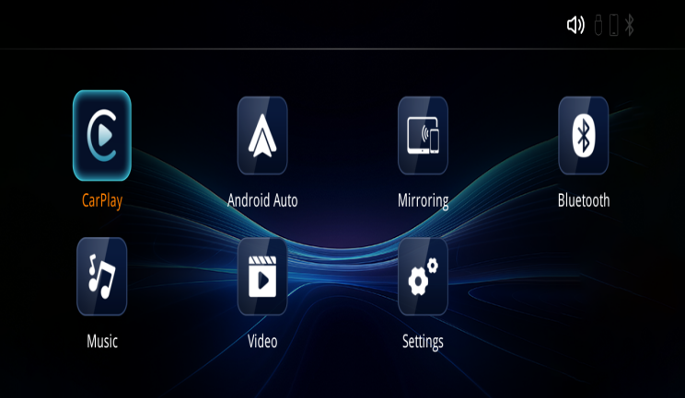
B

Mirroring Media
CarPlay

Ico | Function Description
 | CarPlay:Supports wiredandwireless connections
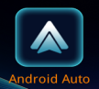 | AndroidAuto:Supports wiredandwireless connections
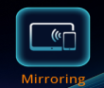 | Mirroring:Supports wired and wireless connections for Apple and Android phones
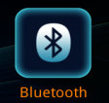 | Bluetooth: iPhone&Android phone Bluetooth connection
 | Music:Plays local USB music,supports FAT32 USB format
 | Video:Play local USB drive video,supporting FAT32 USB drive format
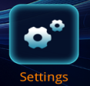 | Settings:System entry points for various functions

3.1 System Settings
Regarding system settings, display the main interface settings of the onboardsystem.The main interface has a【 Settings 】 button, which can be directlyclicked to enter the settings main interface. As shown in the following figure:various pages of the system
System Settings General Settings page
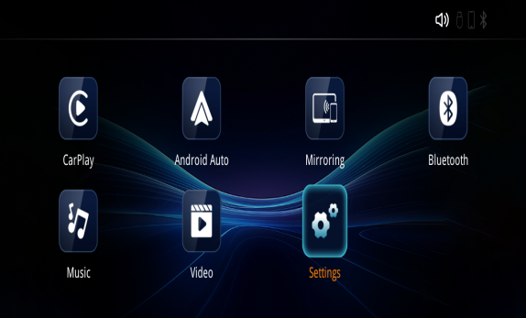

3.2 General Settings
Adjusting volume
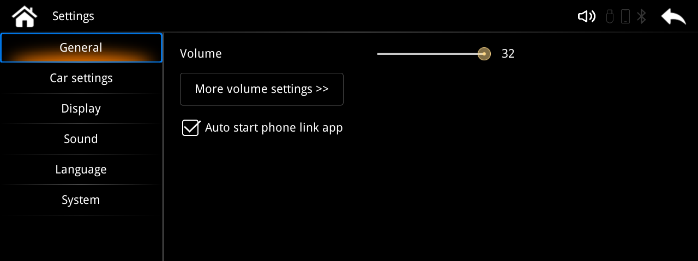

Settings
0
32

Control volume

After checking, set to: Select whether to automatically enter mobile Internet mode after entering the system.

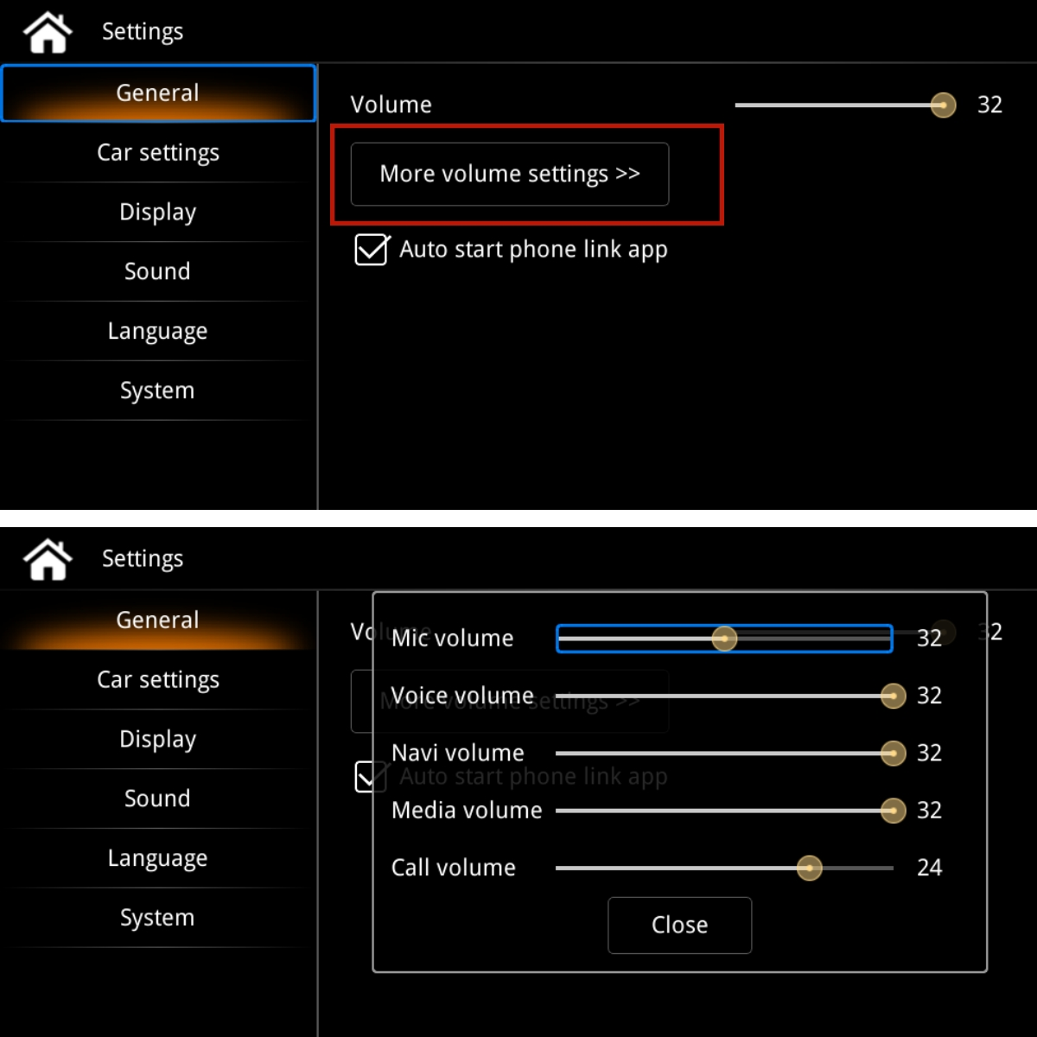
Click >More Volume Settings>> to adjust the volume of common audio.

3.3 Original car settings
Original vehicle settings - Set the reversing image type, reversing track switch, front view camera switch, duration, and microphone type.
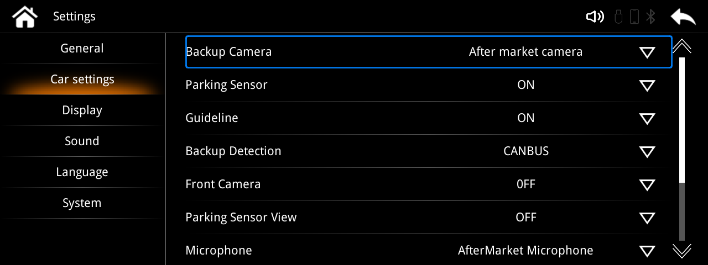

Set the reverse
Reverse trajectory switch.
Front camera, swith,duration.
Microphone type.
3.3.1 Set the reverse image type
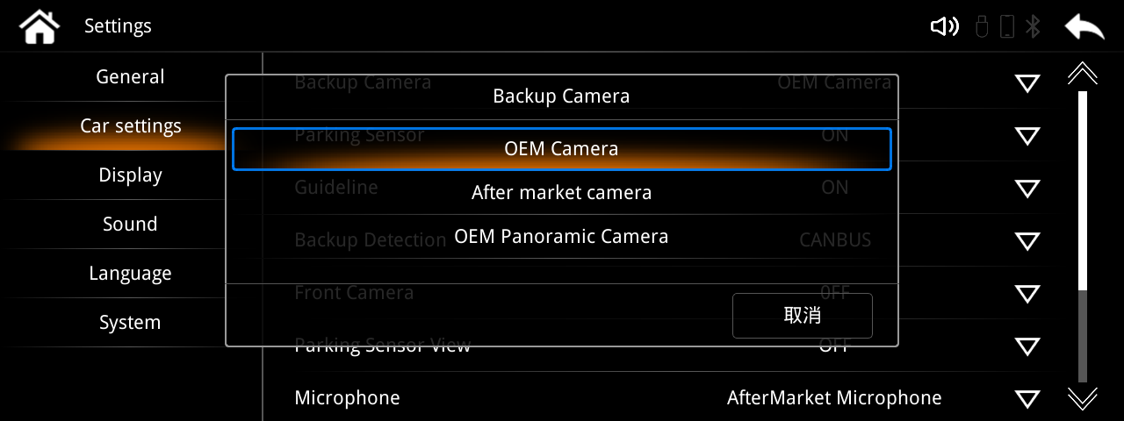
Reversing image settings > Original car camera > Rear-mounted camera > Original car panoramic image.

3.3.2 Set the front view switch and duration
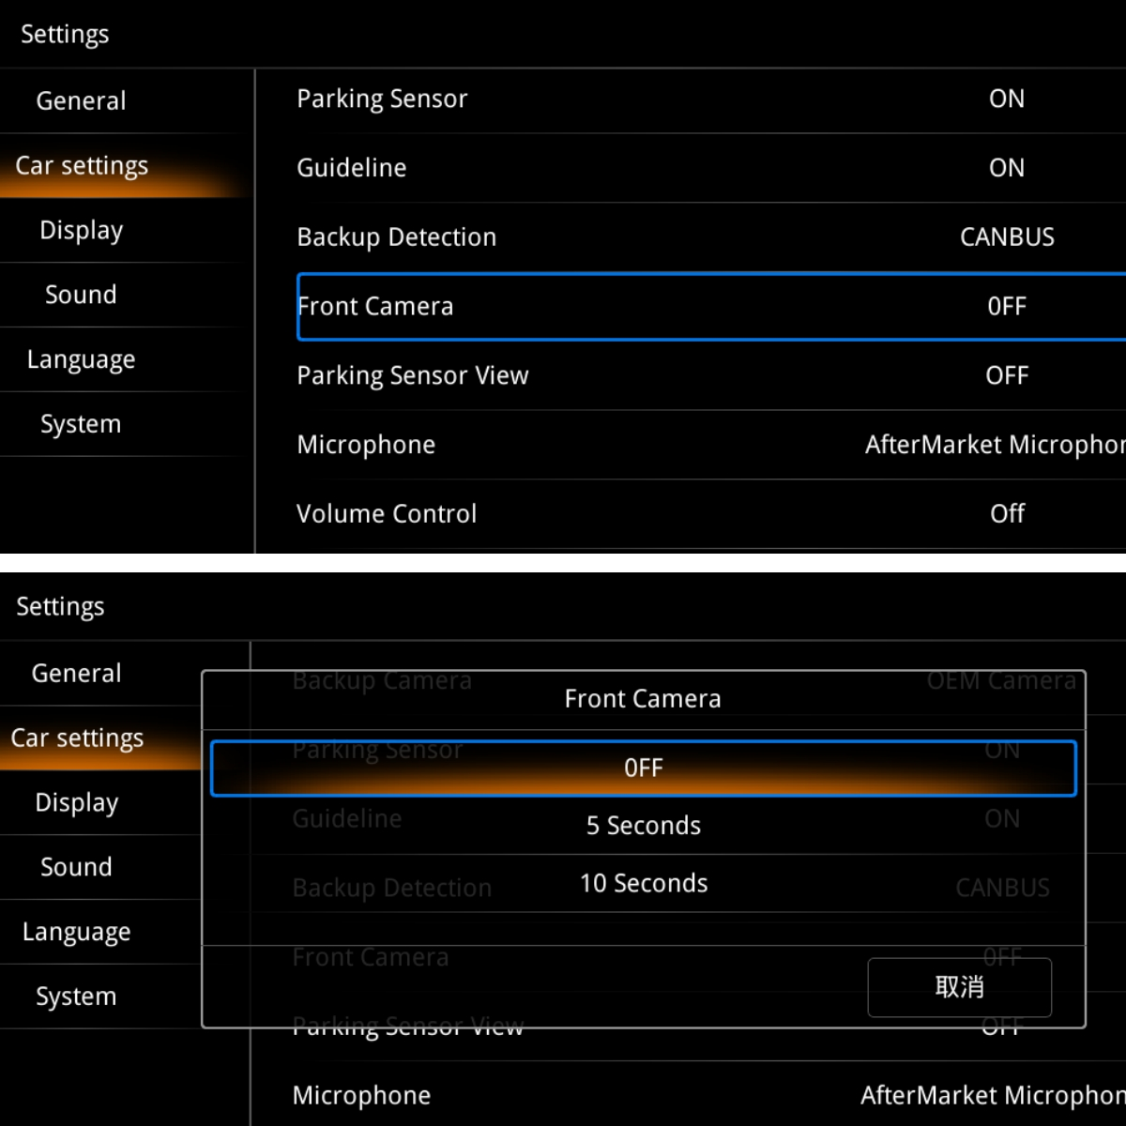
Front Camera Settings > Duration can be set to 5 or 10 seconds.

3.3.3 Set microphone type
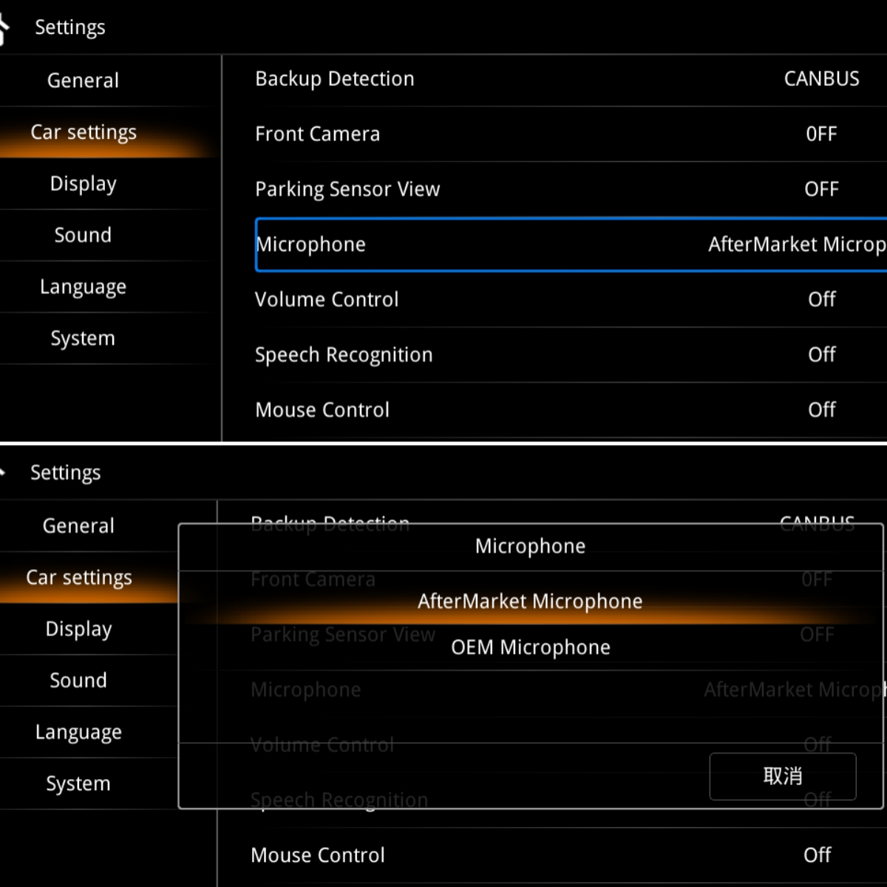
The microphone can be set as a rear-mounted microphone or an original microphone.

3.4 Display Settings
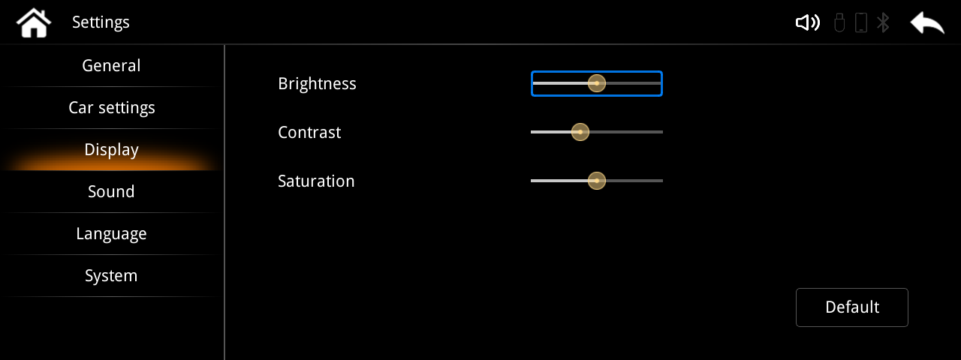
You can adjust the brightness, contrast, and saturation according to your preferences.
3.5 Sound effect setting
You can adjust the sound effects according to your preferences.
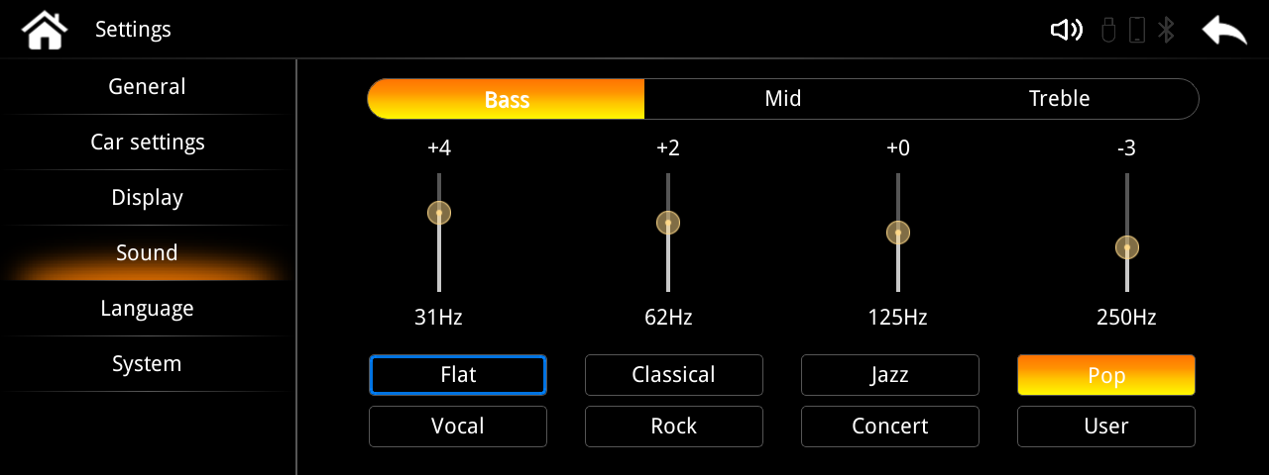

3.6 Language settings
Language-Set system language,supporting multiple language choices.
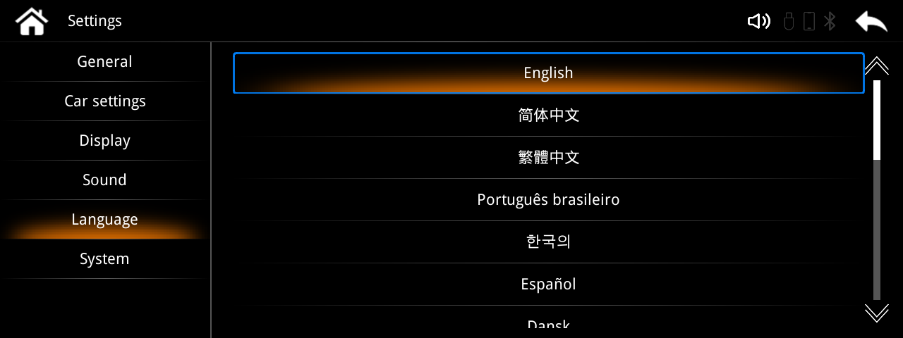

3.7 System settings
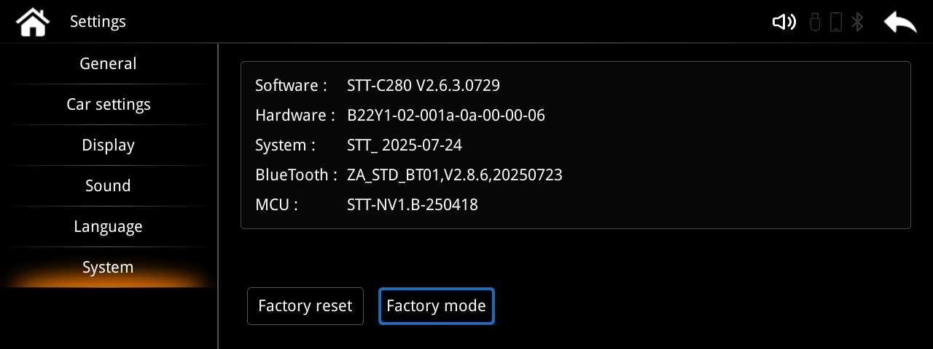
System-can view system version information and enter system factory mode on this page.

3.7.1 Phone link settings
You can adjust the hotspot frequency band > video frame rate > screen ratio.
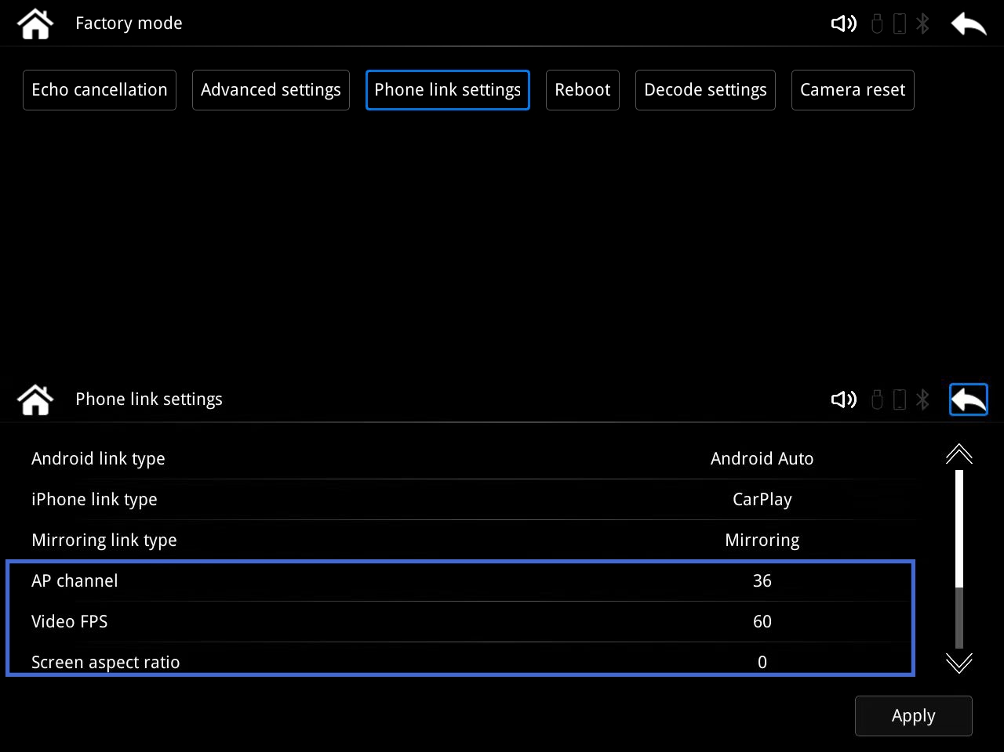
F

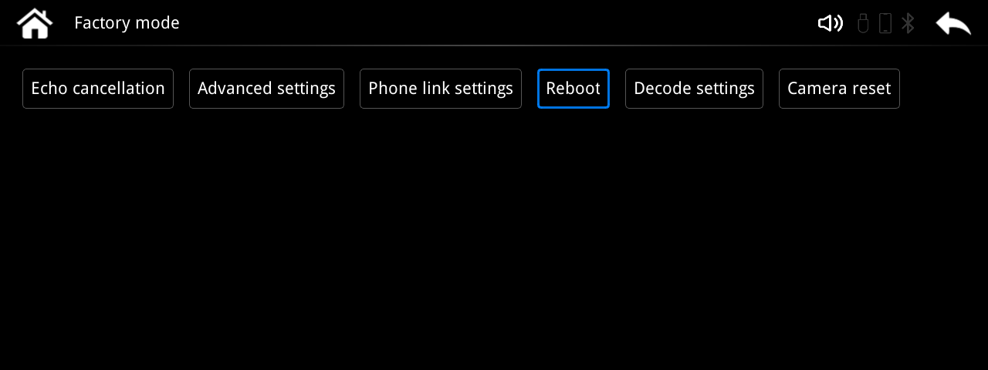
After changing the settings, return to the Factory Mode> page and
click "Reboot" to take effect.

4 Parameter

Supported voltage:9-16V,14.4V(rated) | Storage temperature:-30 to+85 degres Cesius
Working tempera ture:-30 to+75 degrees Celsius | Environmertal temperature:c98%(245 dagres Cesiusl,65%frated)
Pixel:1024*600 high-definition pixels | Wireless transmissior 5G
Power current:1A(rated),3A(Max) | Power outage current:300mA(Clock is on)
Static current:less than 3mA
Charging voltage:lessthan 1.5A.When the USB charging curent s greater than 3A,the host should
activate the electrical protection mechanism to control the current within 1.5A and avoid burning the product

5 Aux Connection
5.1 Connect the original vehicle AUX
If the original car has AUX, select AUX on the original car media interface.

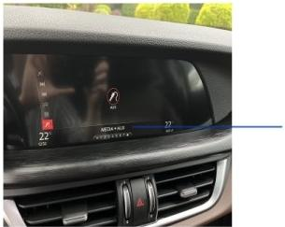

Select AUX Audio.

Click the "Bluetooth" option on the system home page to enter the Bluetooth connection interface.Search for this device on the mobile phone Bluetooth page and connect.
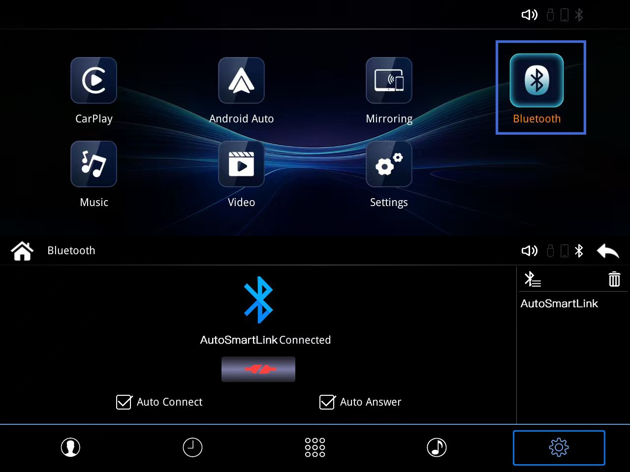

1.Turn on your phone's WIFI and keep it on. 2. Open the Bluetooth page of your phone and search for the connected device via Bluetooth.
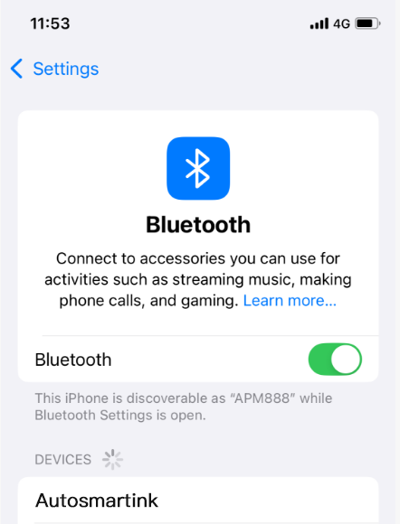
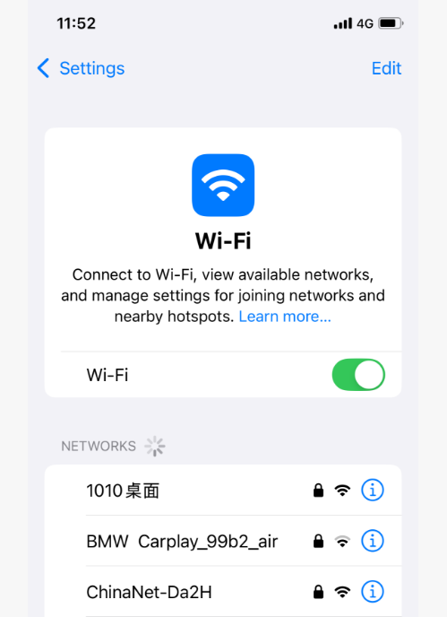

3. Allow devices to pair. 4.Enable Carplay and click Connect.
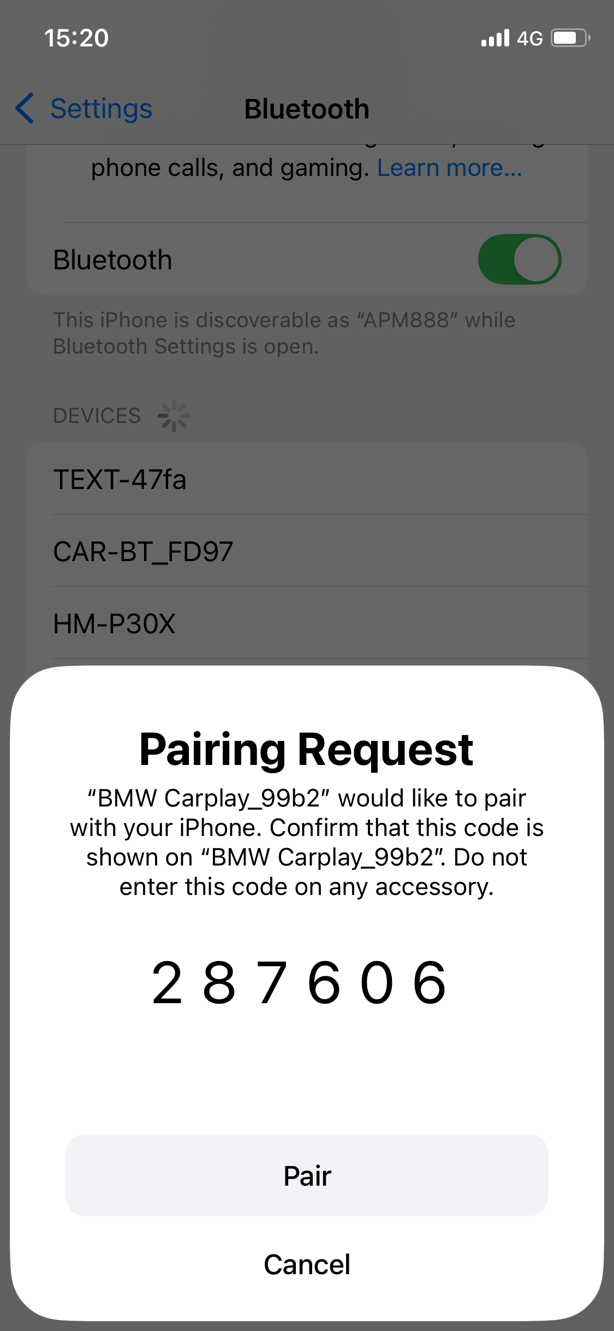
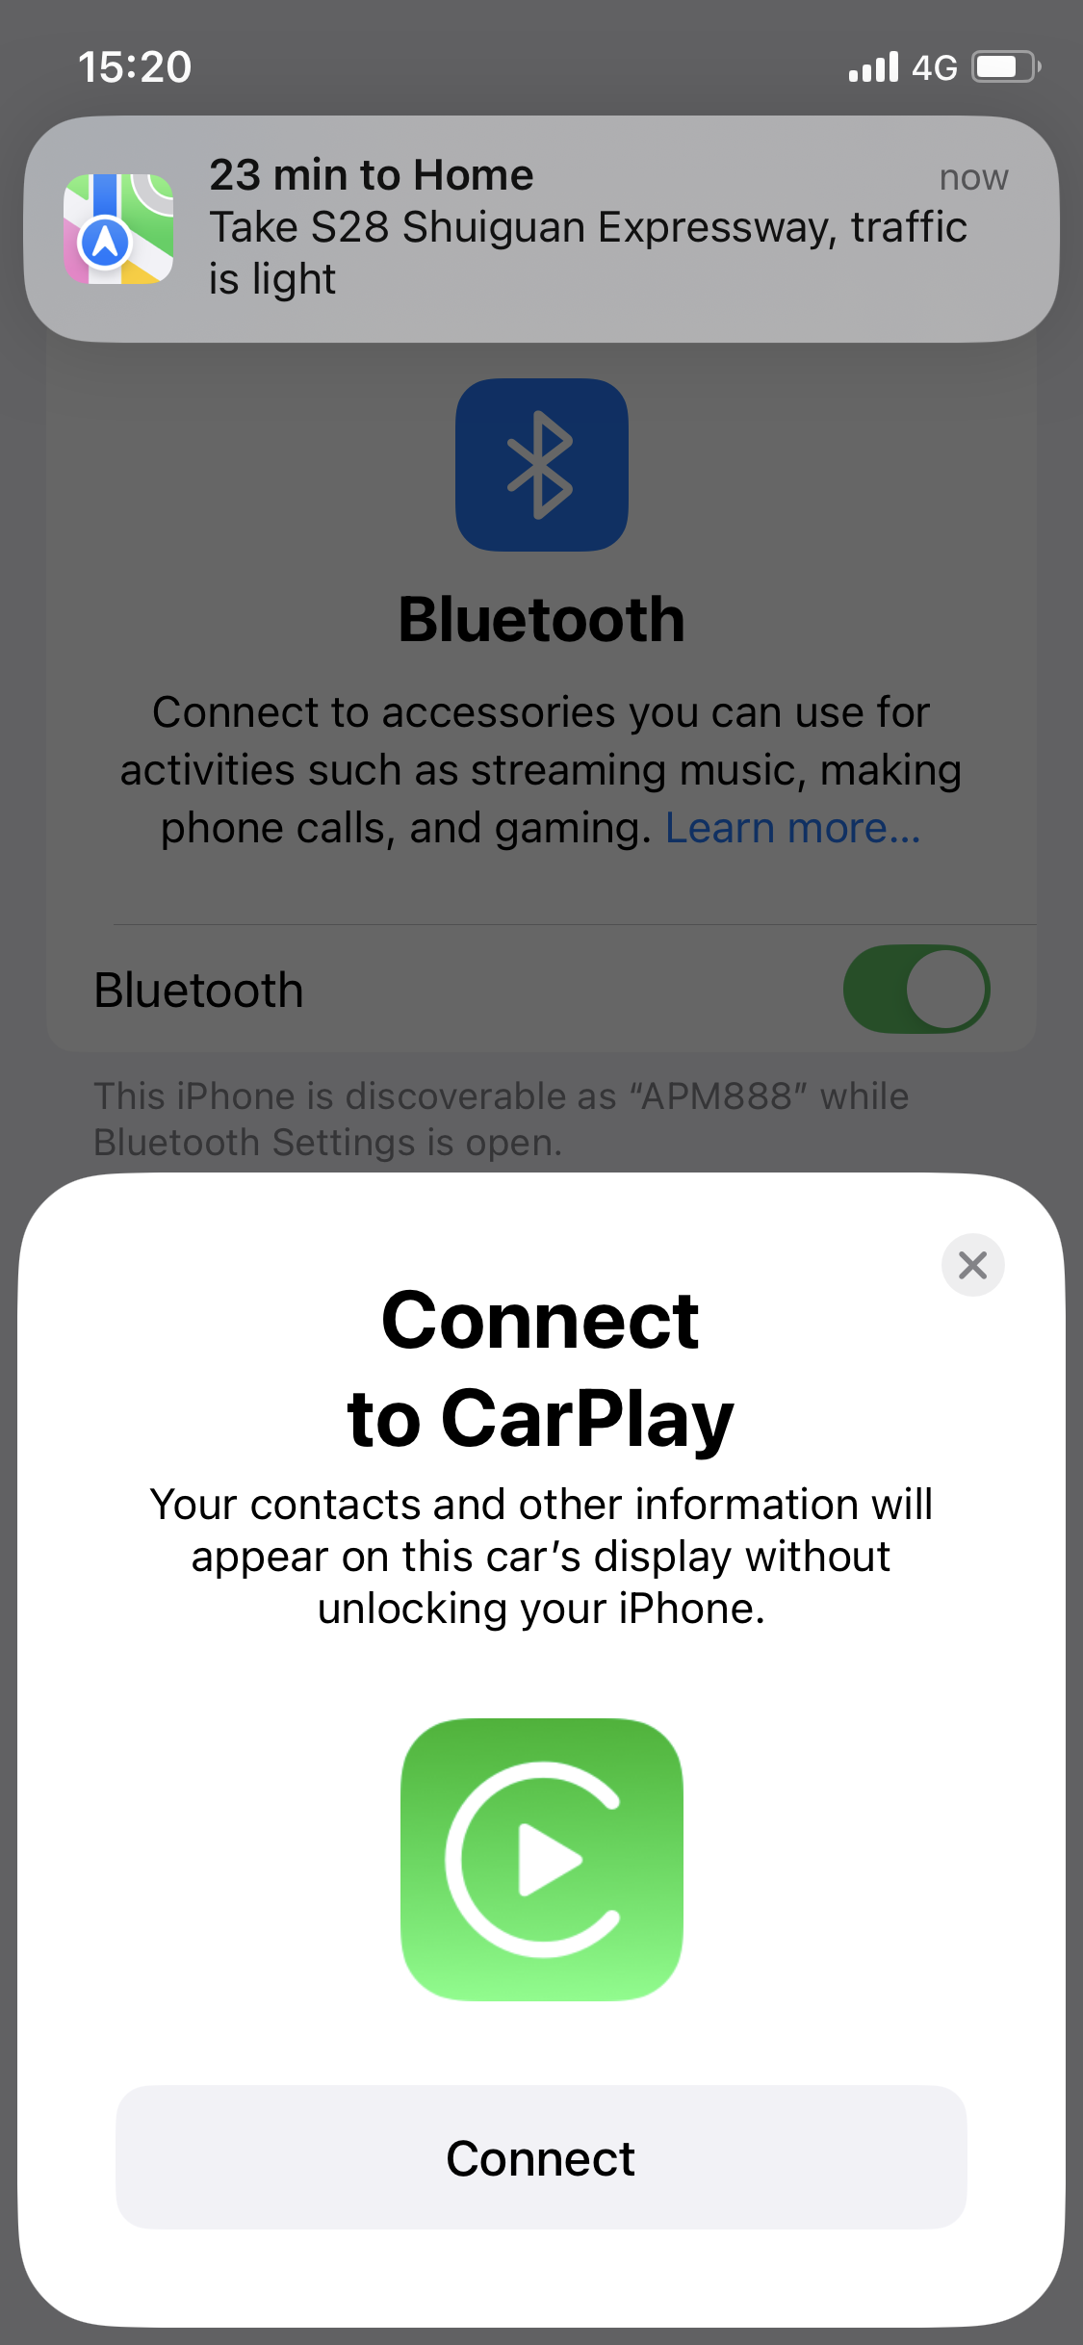

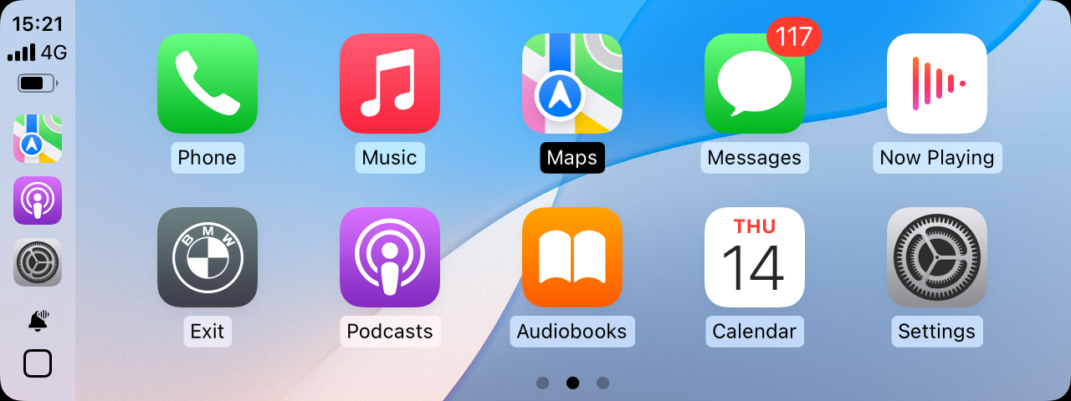
5After a successful CarPlay connection, you can enjoy wireless CarPlayand the system also supports wired connection. Simply connect the USBports of your phone and device with a data cable, without the need forthe above operation.
Click the "Bluetooth" option on the system home page to enter the Bluetooth connection interface.Search for this device on the mobile phone Bluetooth page and connect.

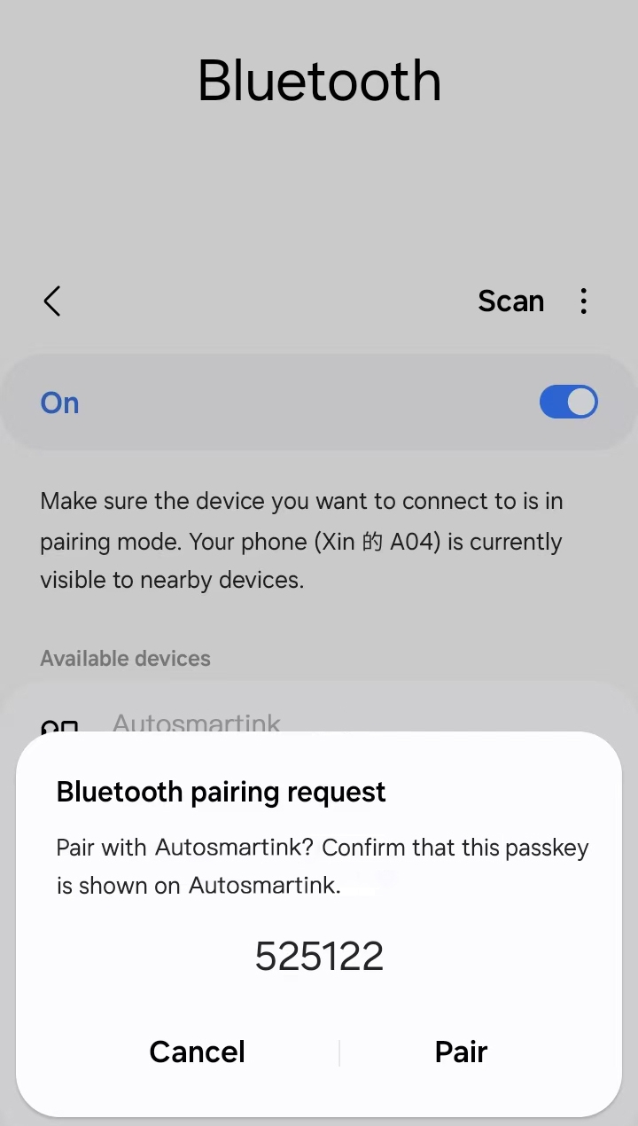
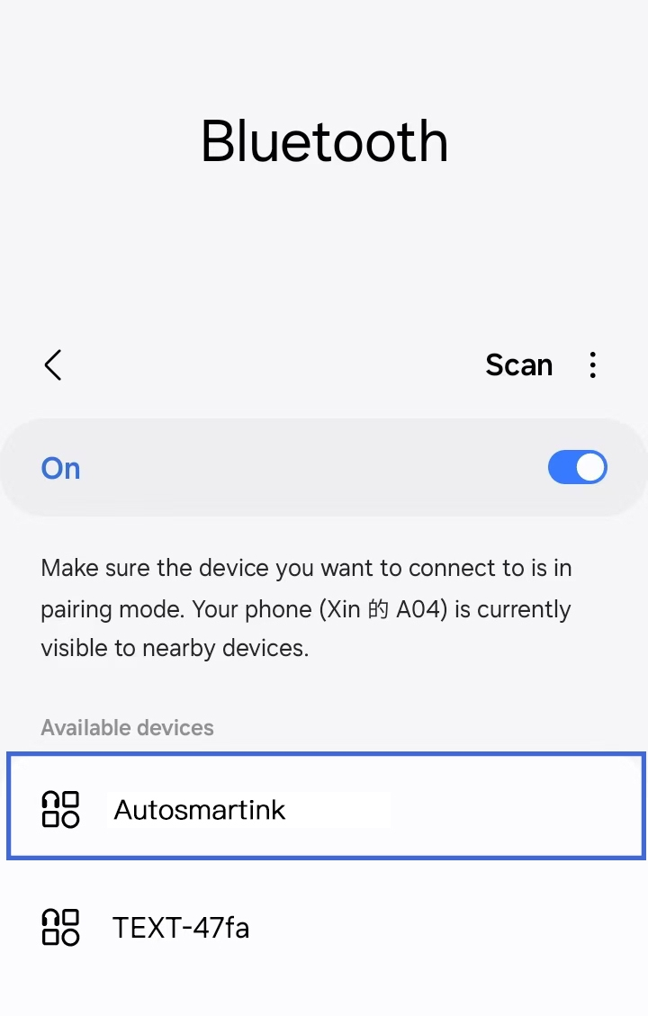
1. Open the Bluetooth interface 2. Click Confirm Pairing.
of your phone and search for
connected devices via Bluetooth.
3.After a successful Bluetooth connection,it will automatically connect to Android Auto,and wired connection is plug and play,without the need for the above operation
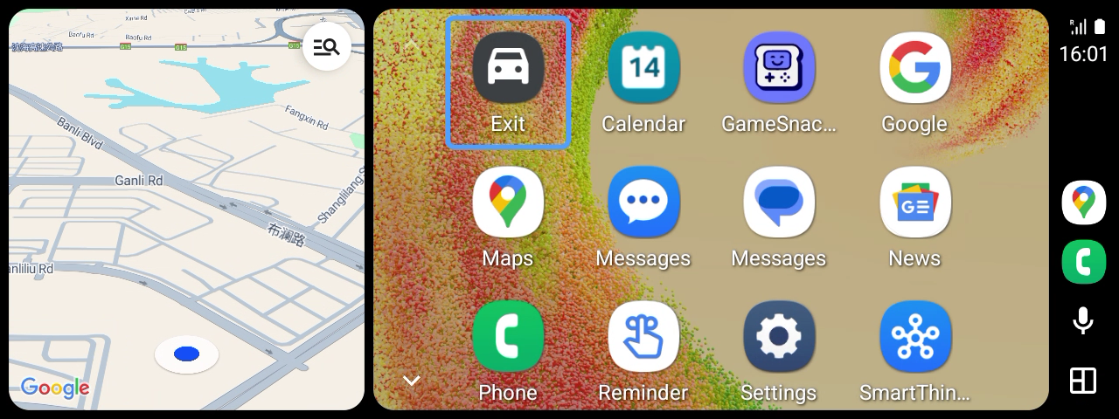

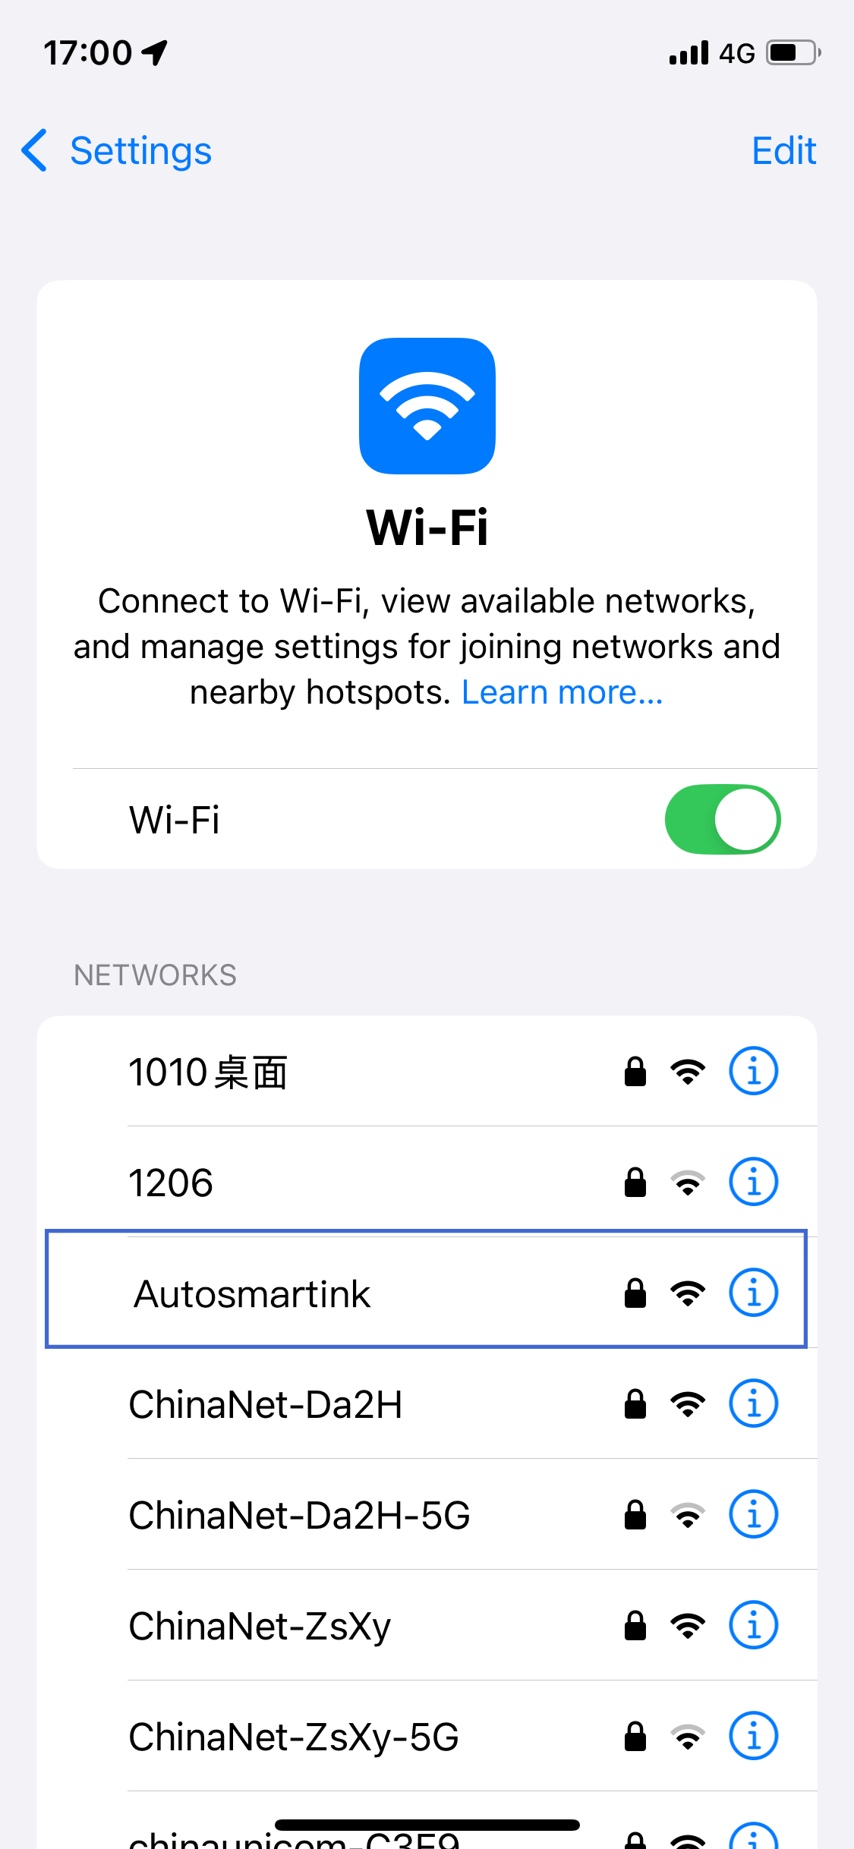
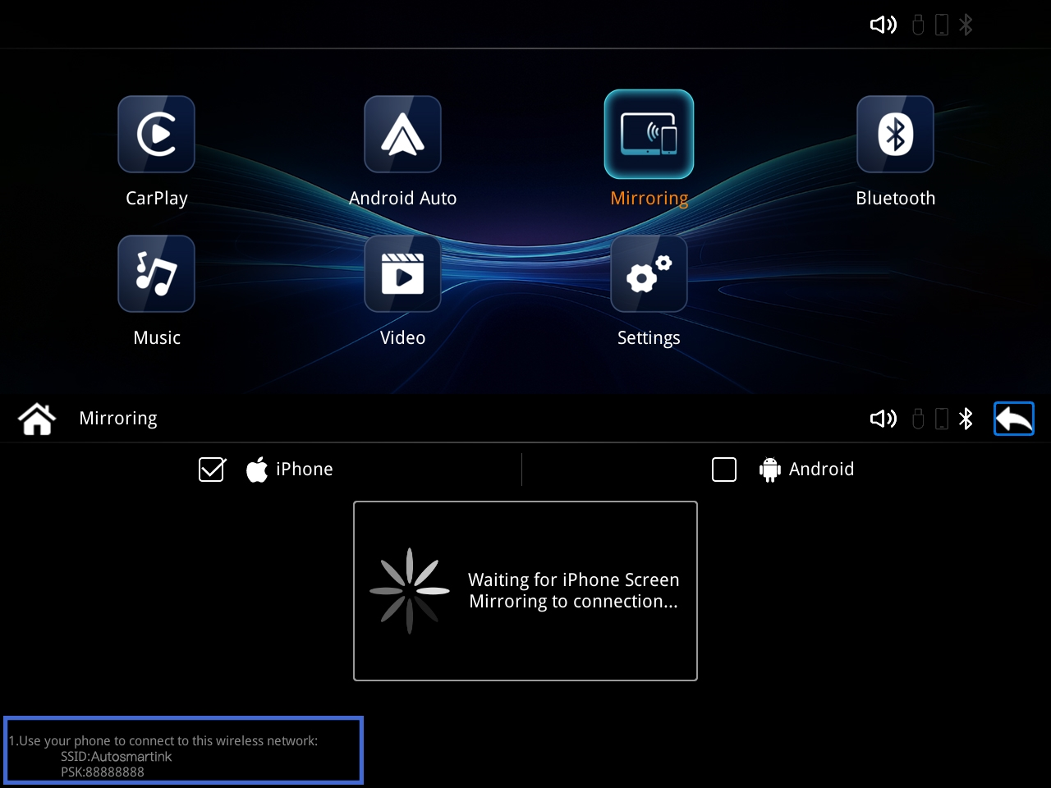
Click the Mirroring icon on the main system interface to enter the Mirroring connection interface.
1.Enter the mobile phone WIFI page,
search for the device and enter
the password to connect.
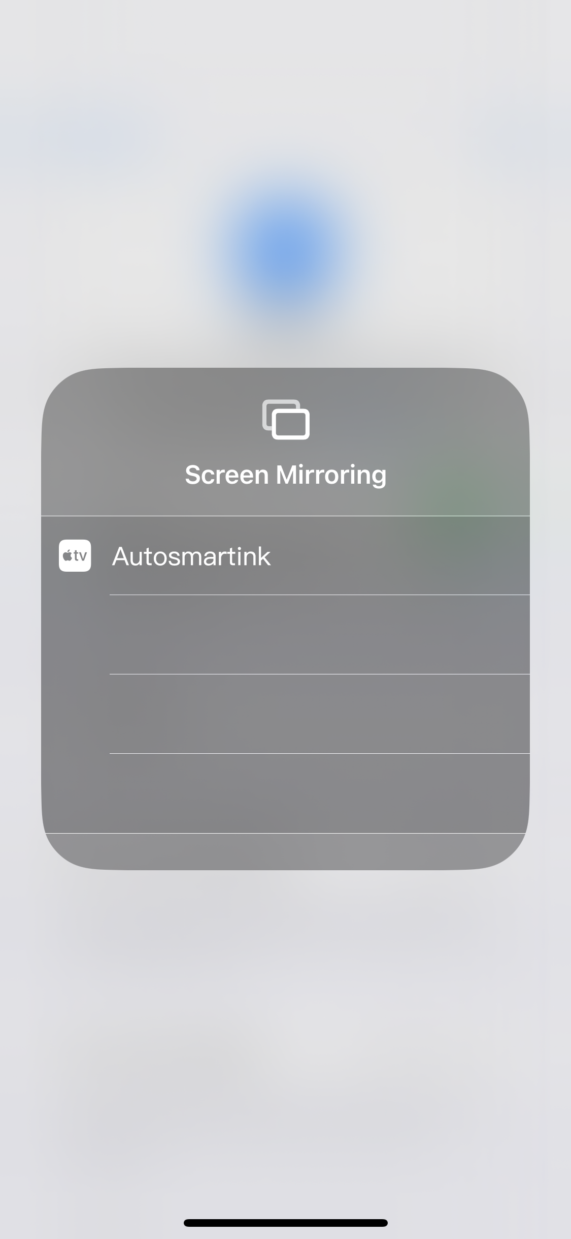
2. Open the shortcut menu on your phone and turn on screen mirroring.

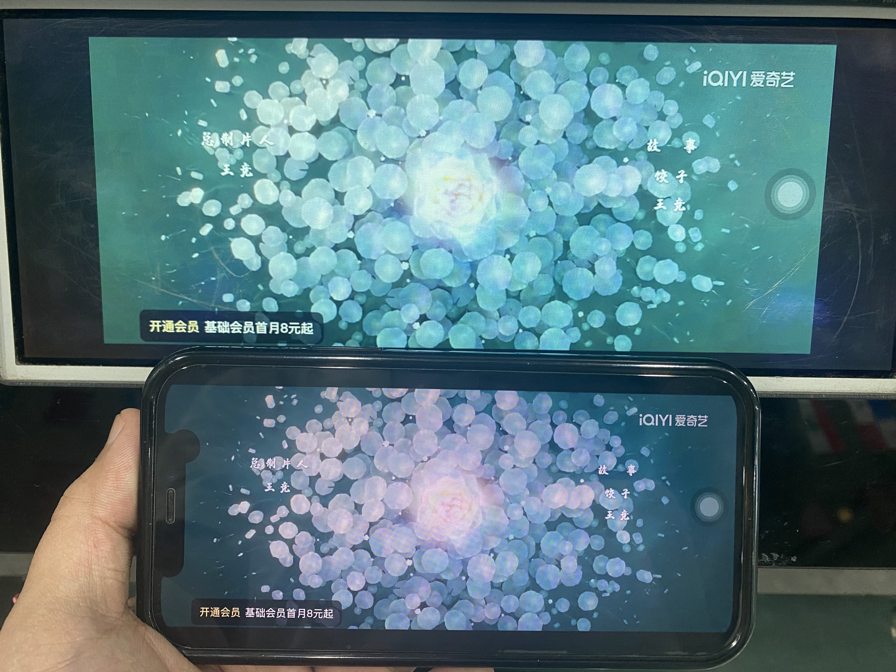
Connection successful! The image on your phone can be synchronized to the car screen in real time.
8.2 Android phone connection method
》
Click the "Mirroring" icon on the main system interface to enter the Mirroring connection interface.
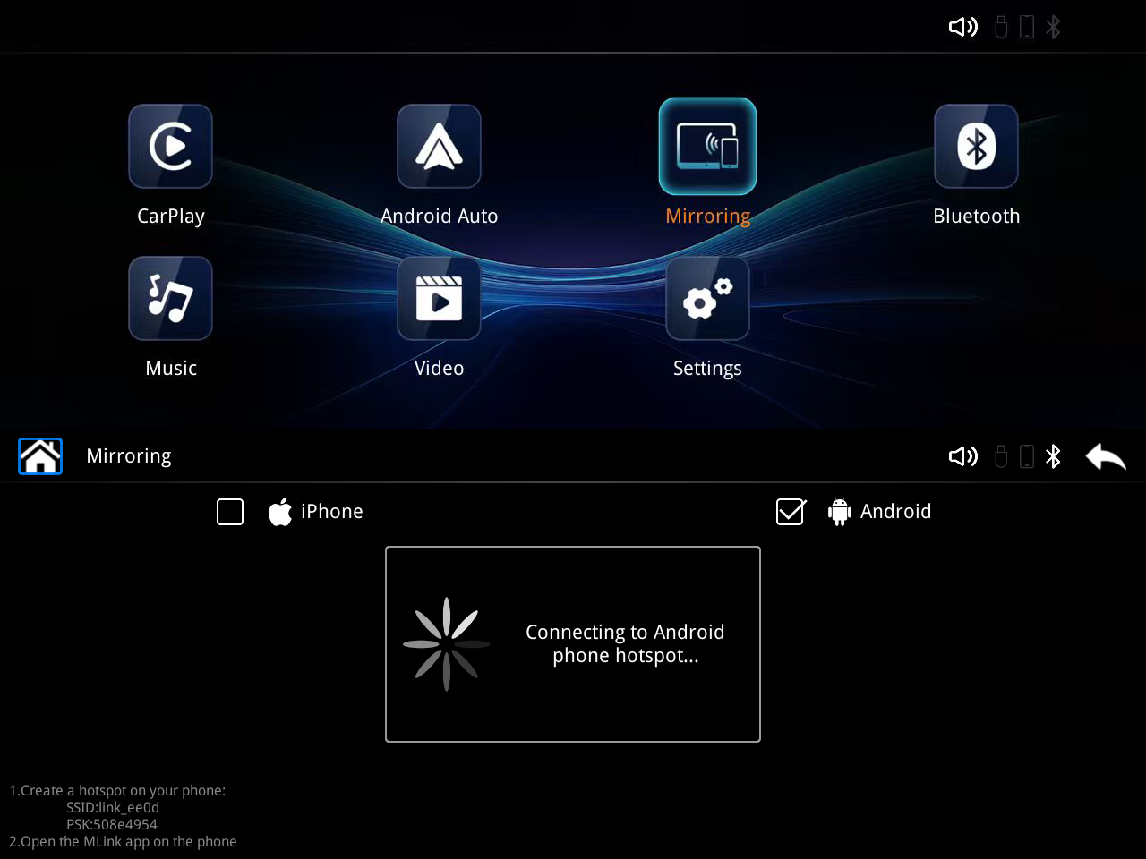
Please connect Android Bluetooth

2.0pen the MLink ap on the phone

Note: To use the Android wireless screen projection function, you need to download the "MLink" software and contact JoyeAuto after-sales technical staff to obtain the "Android Wireless APK Software".
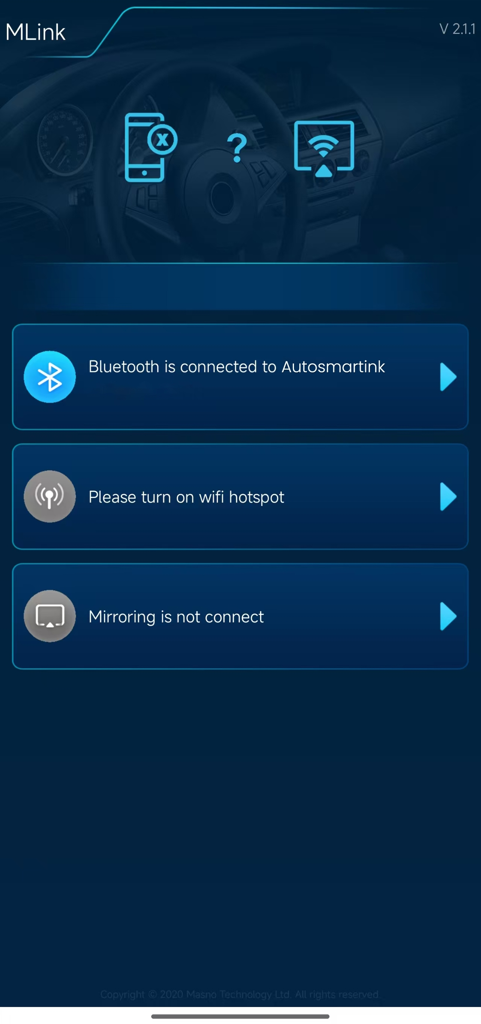

1. Turn on your phone's Bluetooth, search and connect to your device's Bluetooth, and confirm pairing.
2. Enter the phone settings function, find "Personal Hotspot", set the name and password of "Personal Hotspot" to be the same as the name and password prompted on the "Mirroring" interface.

3. Return to the main interface of the phone and open ‘MLink’ to use wireless screen projection. Wired connection is plug and play, no above operations are required.

9.Common problem solving

1、WhyIs CarPlay sllent?
1:CarPlay uses the original AUX audio,so you need to select AUX on the original car's media
interface to have it available Sound.Some car models,such as Mercedes Benz NTG4.0 NTG4.5 system
models,have two types of AUX:AUDIO AUXand Video AUX.It is necessary to ensure that the AUDIO AUX remains open in the original engineering mode to make any sound.
2:Mobile phones cannot connect to vehcle Bluetooth or other external devics,otherwise it will occupy Carplay audio and cause No sound
3:Some vehicles have fiber optic multimedia hosts,which are all audio sources for the vehicle.Main Line of Original Car Media The fiber optic cable above needs to be unplugged and inserted into our 48PIN power cord fiber optic port,and then into the multimedia host.
2、Why does the orlglnal factory rearvlew camera go black when shiftlng to reverse gear after Installing the Carplay module
Because the car module has a rear view interface function,the black screen enters the car
reverse screen.The original factory rearview camera needs to enter the in car system settings interface,find camera settings,rearview camera settings,and select the original camera;If it is a rear view camera and
connected to a module,please select the rear camera in the rear camera settings.Please also checkif the camera circuit is powered on If itis a manual transmission car,a 12Vline needs to beconnected to the module back line at the rear reverse light.

3、After Installatlon,switch the Carplay Interface to black screen,Incomplete dlsplay,and flashlng screen
Thisis because the side dial of the module is incorrect,and different screen sizes have different dial
switches Please adjust the corresponding screen dial according to the dial table on thefront of the module

4、Why cannot I Iisten to the original car radio when using Carplay/Androld Auto
Because the sound of Carplay uses the original car AUX audio and is not the same audio as the radio,it cannot be used simultaneously.For example,you cannot listen to the radio while playing Bluetooth music. If you want to listen to the radio while using the Carplay function,we suggest downloading the Radio app on your phone and then using it on the Carplay/Android auto interface.

5、Why can't my phone connect and keep scrolling through the connection interface?
1:Applephone:requires the phone to automatically recognize the Carplay wireless network.If the phone turns off WIFI on the shortcut interface,it will prompt "Unable to automatically recognize the wireless network before tomorrow",resulting in inability to connectSo please do not tum off WIFI in the mobile shortcut interface unless it is necessary.To turn off,please turn off WIFI in the phone settings.
If there is a connection issue,please keep your phone's WIFIand Bluetooth on and restart your phone once. Alternatively.you can restore the network settings on your phone.

The network and traffic used by the car system come from the mobile phone.When
connecting the car system to wireless CarPlay,the first time it is necessary to manually
connect the car Bluetooth to the phone Bluetooth and keep the phone Bluetooth on.After a successful CarPlay connection,the Bluetooth connection between the phone and the
system will automatically disconnect,and then enter the WIFI authentication channel.The in car system will actively identify dedicated hotspots and transmit pop-up windows to the in car display screen.To install an iPhone wired connection,simply plug in your phone's
data cable to complete the connection.

11.About driving
Drivers should not operate the machine during driving to avoid affecting safe driving and causing traffic accidents.Safety first,smart entertainment secondplease strictly abide by national traffic
regulations!

12.Postscript
At this point,you have gained a comprehensive and easy-to-use understanding of in car system software.You can now operate the car infotainment system and experience the
convenience it brings to your driving life,enjoying the infinite fun brought by high-tech! Wishing you a smooth and safe journey!Due to continuous software upgrades,screenshots of this manual may differ from the version you are actually using,without prior notice

