Introduction
Introduction 01
Safety Precautions 01
System Components 02
System Settings - User Guide 03
CarPlay supports both wired and wireless connections 05
AirPlay:How to mirror the screen of an Apple phone 06
Android Auto wireless connection tutorial. 08
MiraCast: How to mirror your Android phone's screen. 09
2.Function Setting Operation Instructions. 10
2.1 Language Settings. 10
2.2 Display Settings. 11
2.3 Connection Settings. 12
2.4 Bluetooth Settings. 13
2.5 Wi-Fi Settings. 13
2.6 Reverse Settings. 14
2.7 System Settings. 15
2.8 Factory Settings. 15
2.9 Camera parameter settings. 16
3.USB playback operation instructions. 17
3.1Insert the USB drive to play audio. 17
3.2Insert the USB drive to play the video. 17
Common problem solving 18
About Network Usage 20
About Driving Safety 20
Postscript 20

1 Introduction

1.1 Introduction
Thank you for choosing this intelligent vehicle information system.It is a comprehensive
navigation and entertainment system that is convenient for users to use,also known as
thecar infotainment system.Car owners can use their cars to connect their phones for
navigation and voice recognition;When parking,you can plug in a USB to listen to music or watch videos;Or when driving,directly connect to your phone and use the mobile appn
avigation;No longer need to make phone calls with your phone,safe and convenient.The images in this manual are for reference only and are inte nded as fuctional instructions.
Please refer to the actual onboard systemfo r details.If the manual content does not match the actual product due to functional upgrades or other reasons,no further notice will be given.

1.2 Safety precautions
Thank you for choosing this intelligent vehicle information system,which is a comprehensive navigation and entertainment systemmounted on a car.Drivers are not allowed to operate th e machine during driving to avoid affecting safe driving and violating traffic regulations.Thi s machine is an electronic product,please follow the safety precautions of ordinary electronic machines.This machine is powered by a 12V-24V5A onboard power supply.Please do not in sallthe machine on a power supply that does not meet the standards to avoid damaging the machine.Please do not disassemble or assemble without authorization.Professional mainten ance personnel should be responsible for this.Please do not modify system software or upgra de without authorization.Do not use sharp or hard materials to come into contact with the s urface of the host.Do not use in extreme environments,normal operating temperature is -40 to 70.Do not pour liquids or chemicals(such as water)onto this machine.Our company do es not assume any responsibility for the loss or damage of personal information caused by us er's incorrect operation,product maintenance,replacement,or other unexpected situations,n or is it responsible for any other indirect losses caused by this.Our company has the ownersh ip and final interpretation rights of relevant materials such as functiona manuals,warranty certificates,and warranty cards.

The following is the maln page displayed by the In car system

System maln Interface Home page
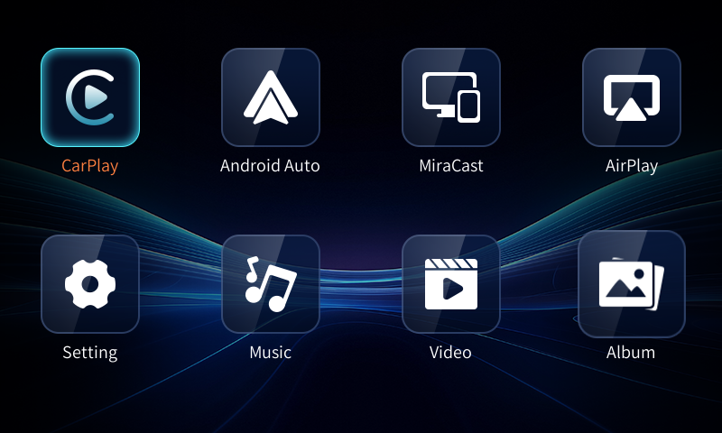
B

Mirroring Media
CarPlay

Ico | Function Description
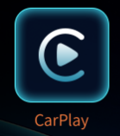 | CarPlay:Supports wiredandwireless connections.
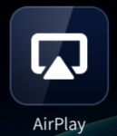 | AirPlay: Supports wireless screen projection from Apple phones.
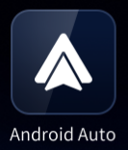 | Android Auto:Supports wiredandwireless connections
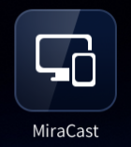 | MiraCast: supports wireless screen projection connection of Android phones.
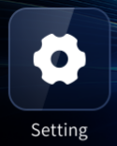 | Setting:System entry points for various functions
 | Music:Plays local USB music,supports FAT32 USB format
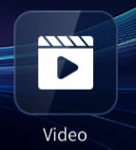 | Video:Play local USB drive video,supporting FAT32 USB drive format
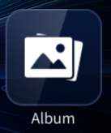 | Album: View local USB flash drive pictures, support FAT32 USB flash drive format

3.1 Wired connection.
Connect via USB cable to enter the Carplay page.

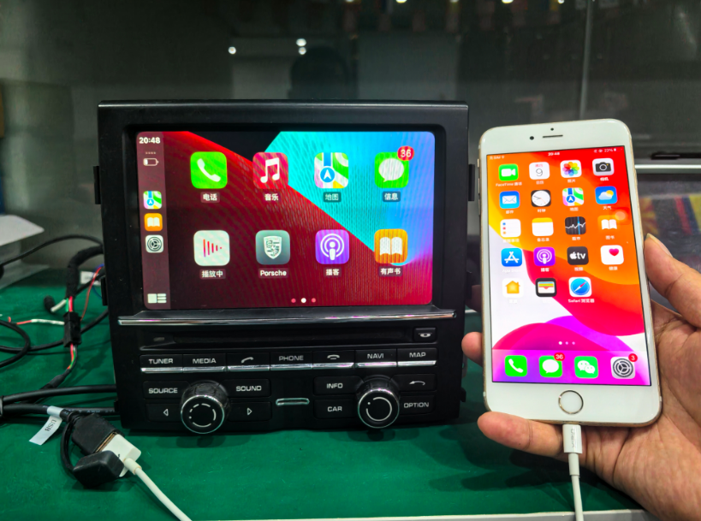
3.2 Wireless connection.
Click the CarPlay icon on the main interface and follow the instructions to connect, as shown in the figure:
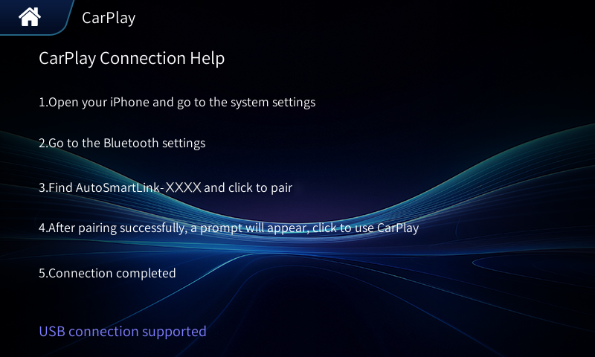

Settings
0
32

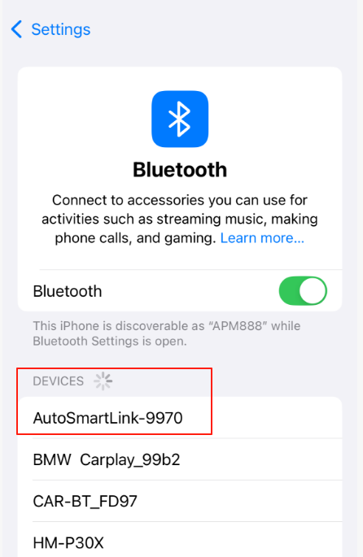
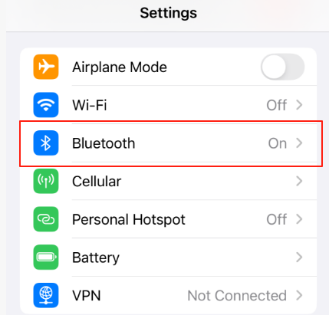
Open the Bluetooth page of your phone and find the Bluetooth nickname of AutoSmartLink-XXXX to connect.

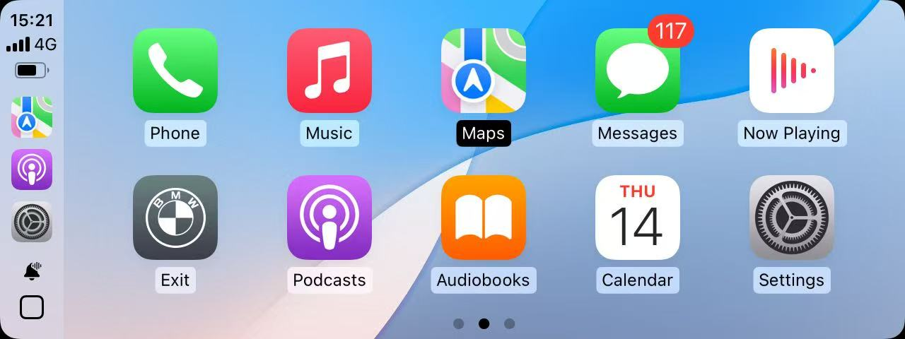

AirPlay: Apple mobile phone wireless screen projection connection tutorial.
How to wirelessly mirror your iPhone to AirPlay
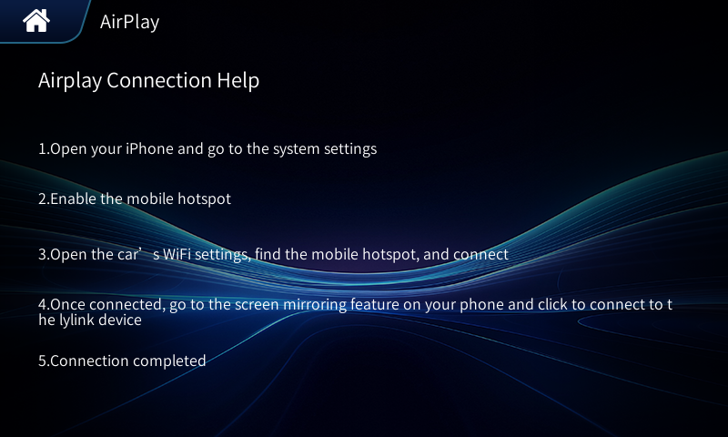
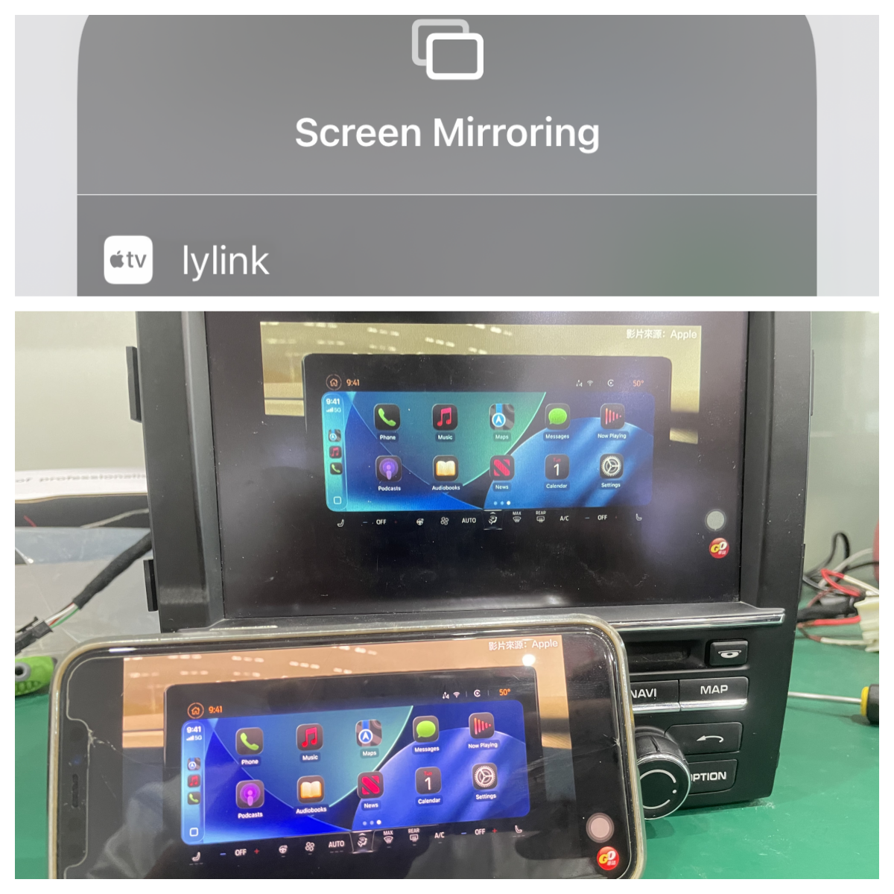
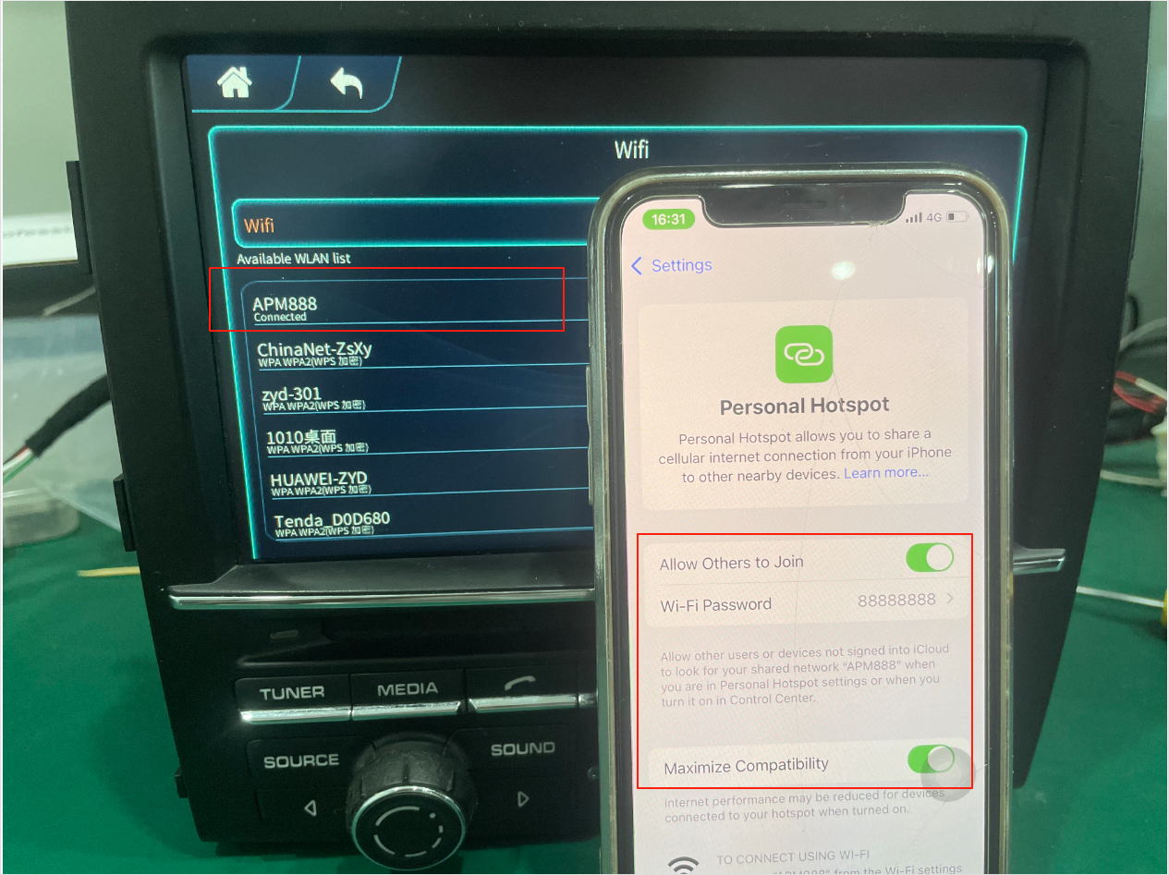
Turn on your phone's hotspot and connect to it through JoyeBox System - Settings - WIFI. Click Screen Mirroring to start screen mirroring.

Click the Android Auto icon on the main interface and follow the instructions to connect, as shown in the figure:
Android Auto wireless connection tutorial.
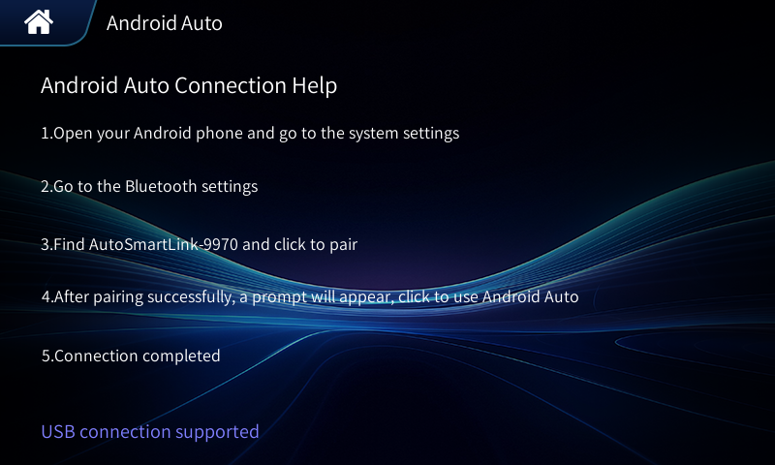

Find the Bluetooth nickname Auto SmartLink-xxxx on your phone's
Bluetooth page and connect.
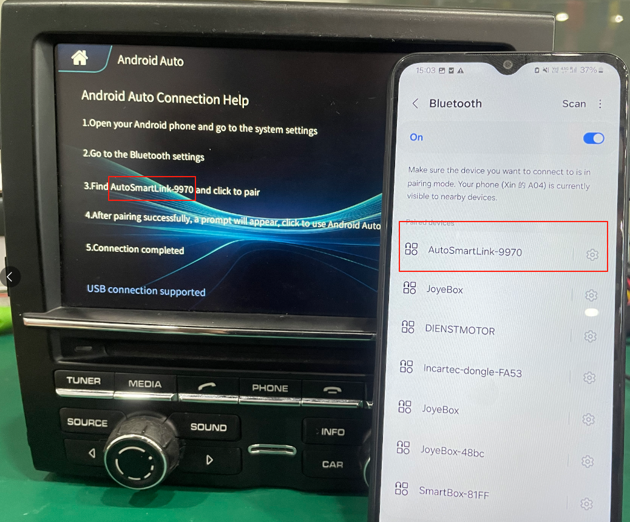
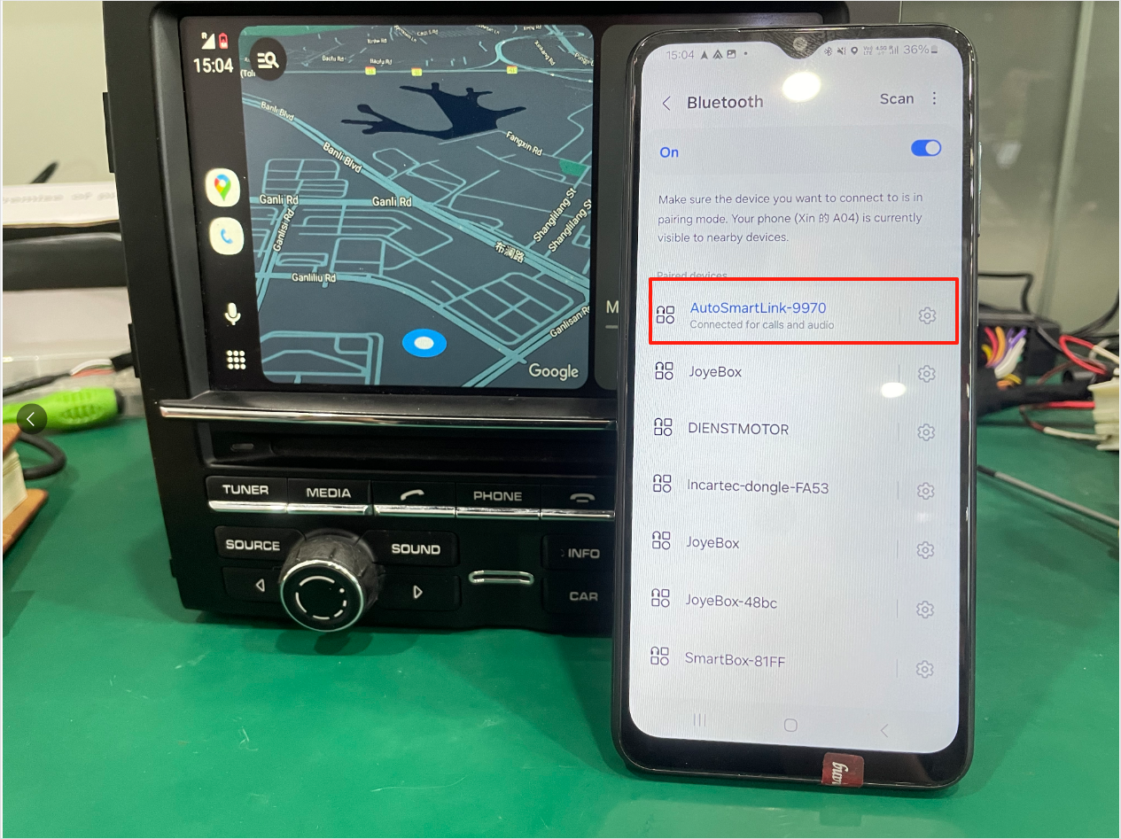
After a successful Bluetooth connection, it will automatically connect toAndroid Auto, and wired connection is plug and play, without the need forthe above operation

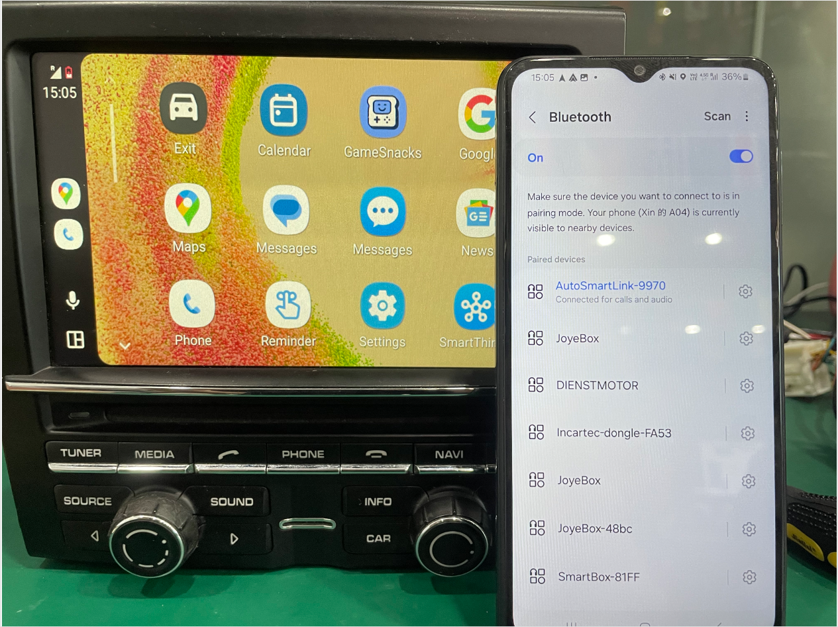
Tap the MiraCast icon on the home screen and follow the on-screen instructions to connect, as shown below:
MiraCast: Tutorial on wireless screen projection from your Android phone.

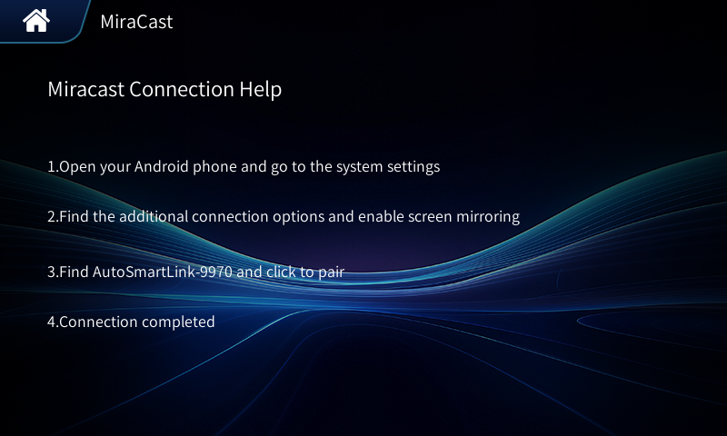

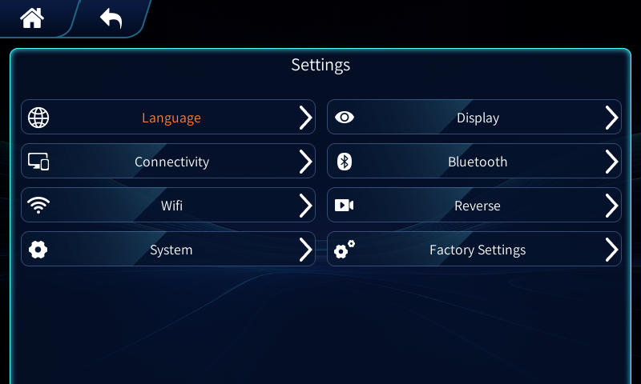
Function Setting Operation Instructions

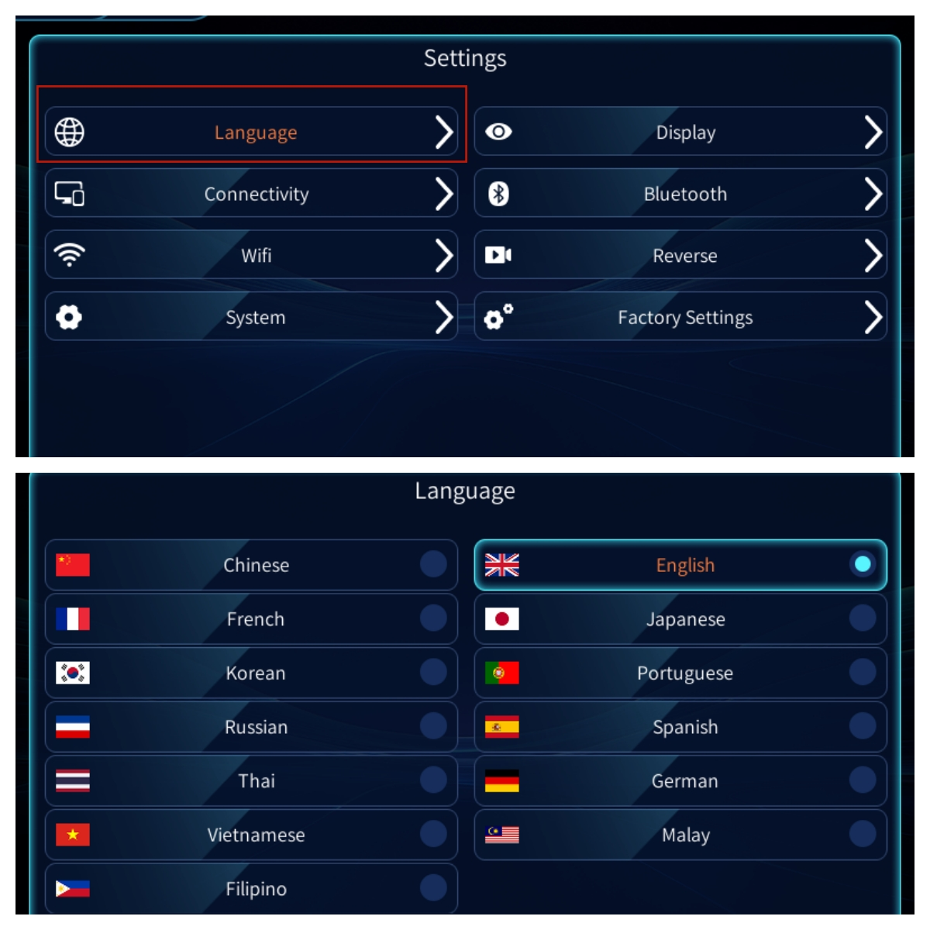
Click on Settings Language, you can change: English, German, French, etc...

Settings - Display - You can adjust the color brightness, saturation, and contrast. As shown in the figure:
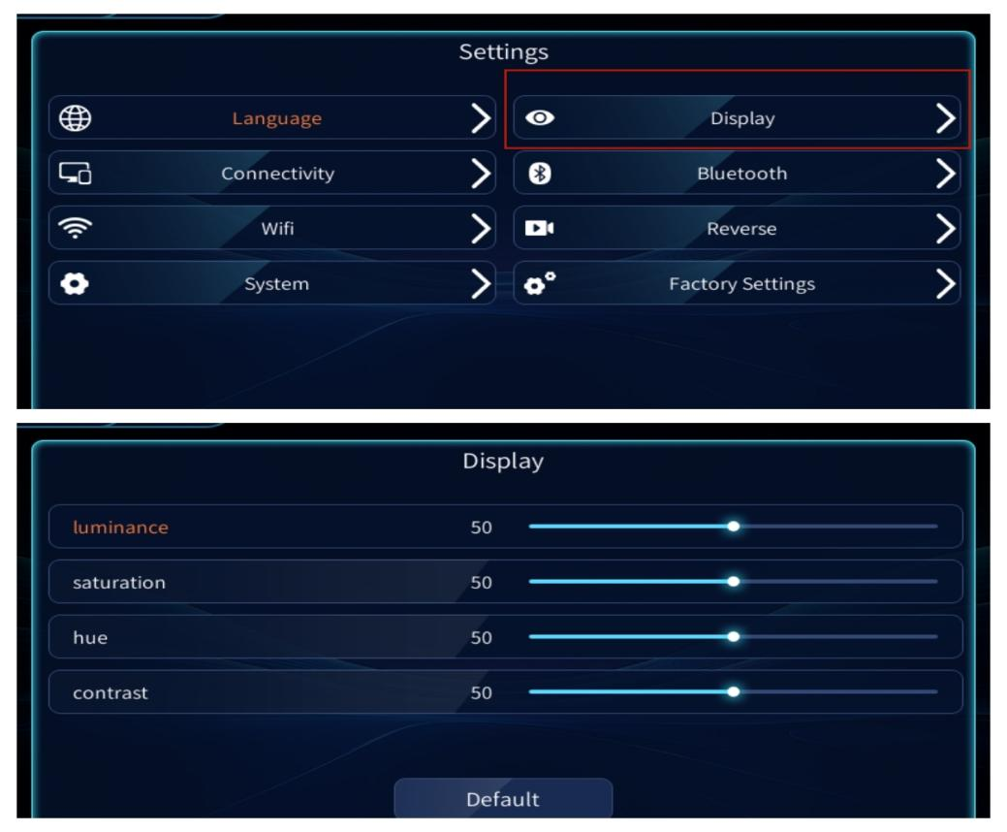

Settings > Connections > Sound come from the car engine. Note: (If your factory system doesn't support Bluetooth music and Bluetooth calls, don't select this setting.)
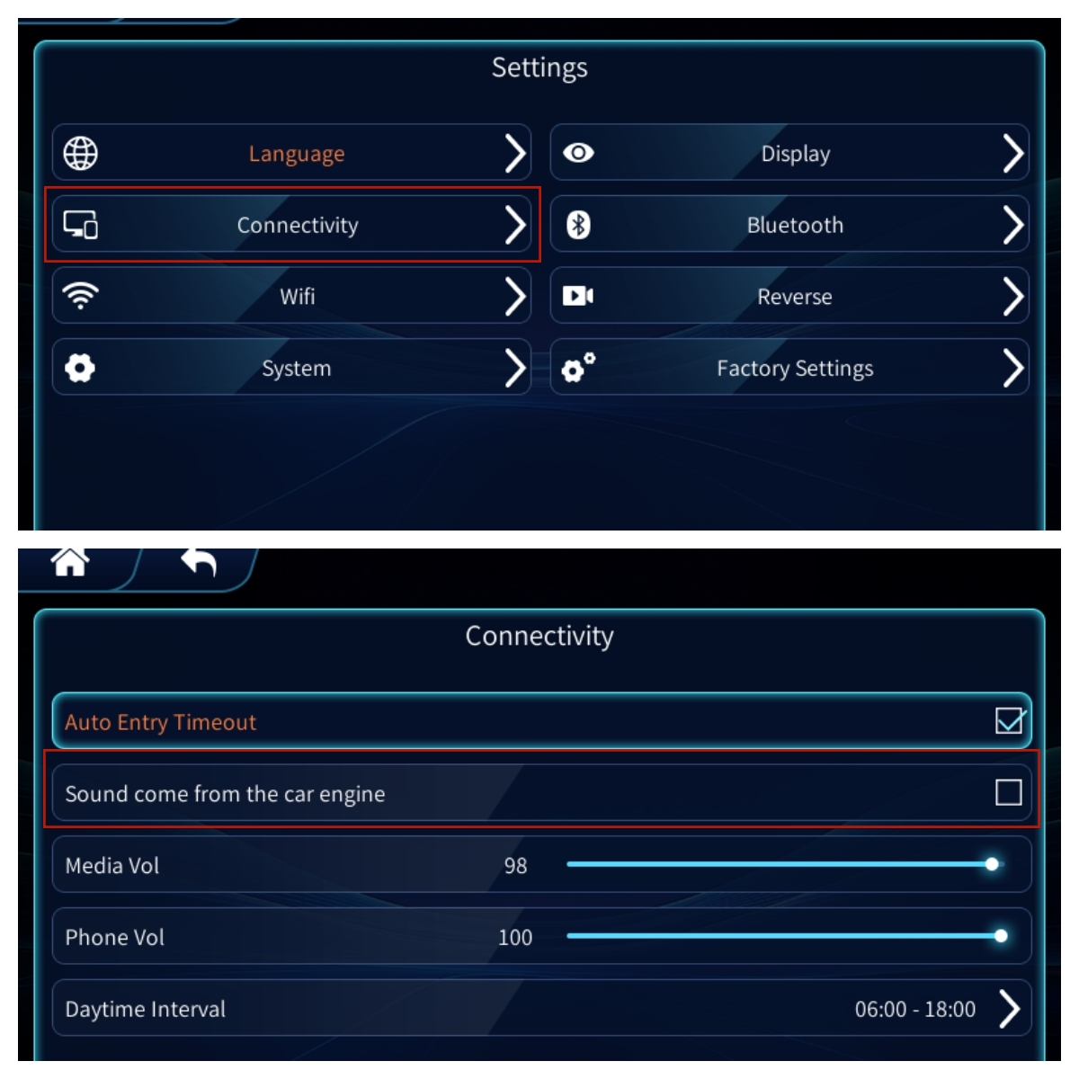
If you're dissatisfied with the AUX sound quality or experience noise in AUX mode, you can enable this setting. Additionally, connect your phone to both CarPlay and the factory Bluetooth. Keep the factory system in Bluetooth mode, not AUX mode. This will allow you to stream audio using the factory Bluetooth and utilize the factory microphone (as shown in the image):

Settings - Bluetooth - View Bluetooth nickname - Add other devices,
As shown in the figure:
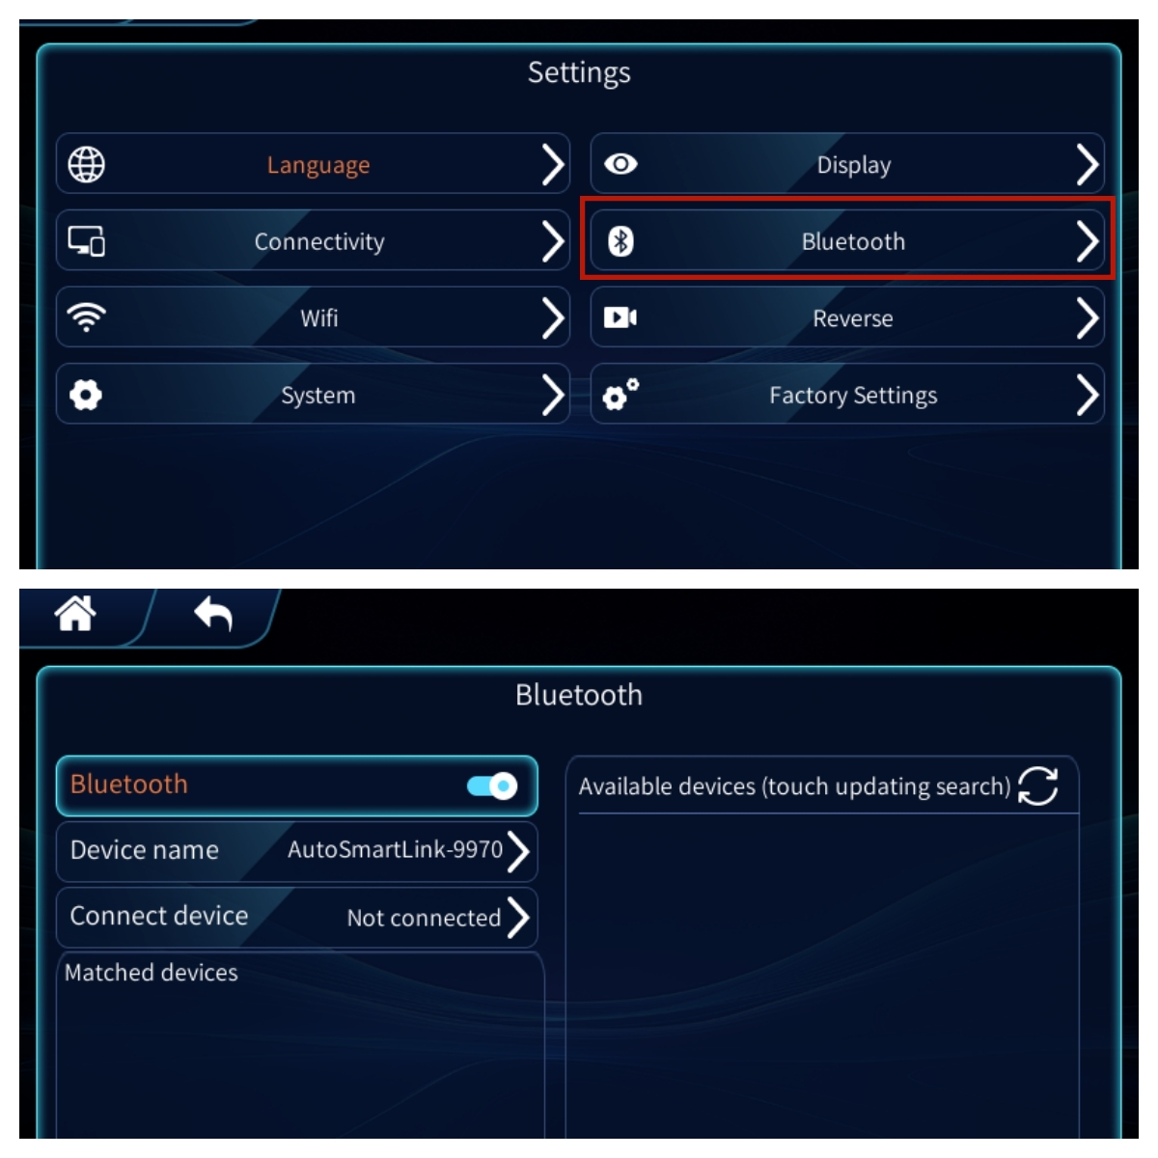

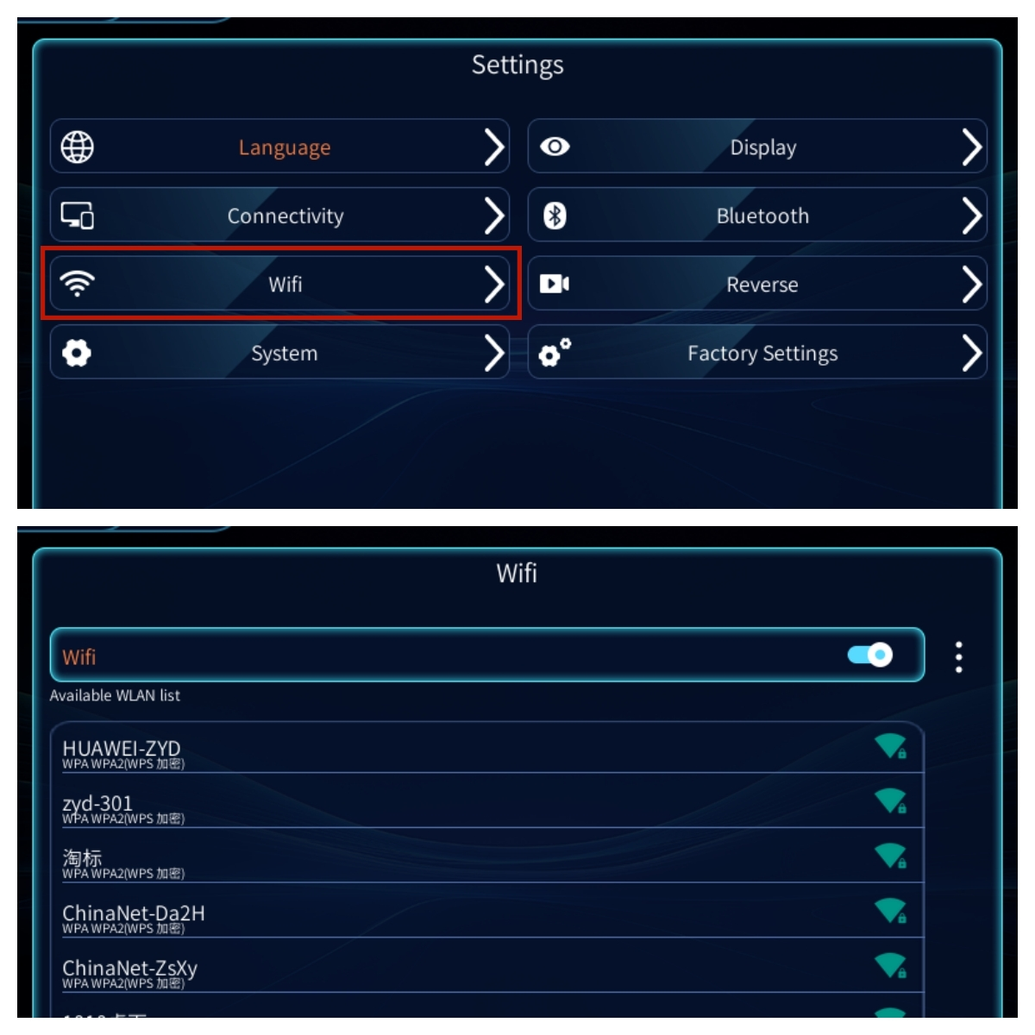
Settings - Wi-Fi - Connect to Wi-Fi for iPhone screen projection,
interface upgrade, etc. As shown in the figure:

Settings - Reverse - Front and rear view settings (if front and rear view is turned off, the default is the factory rear view) as shown:
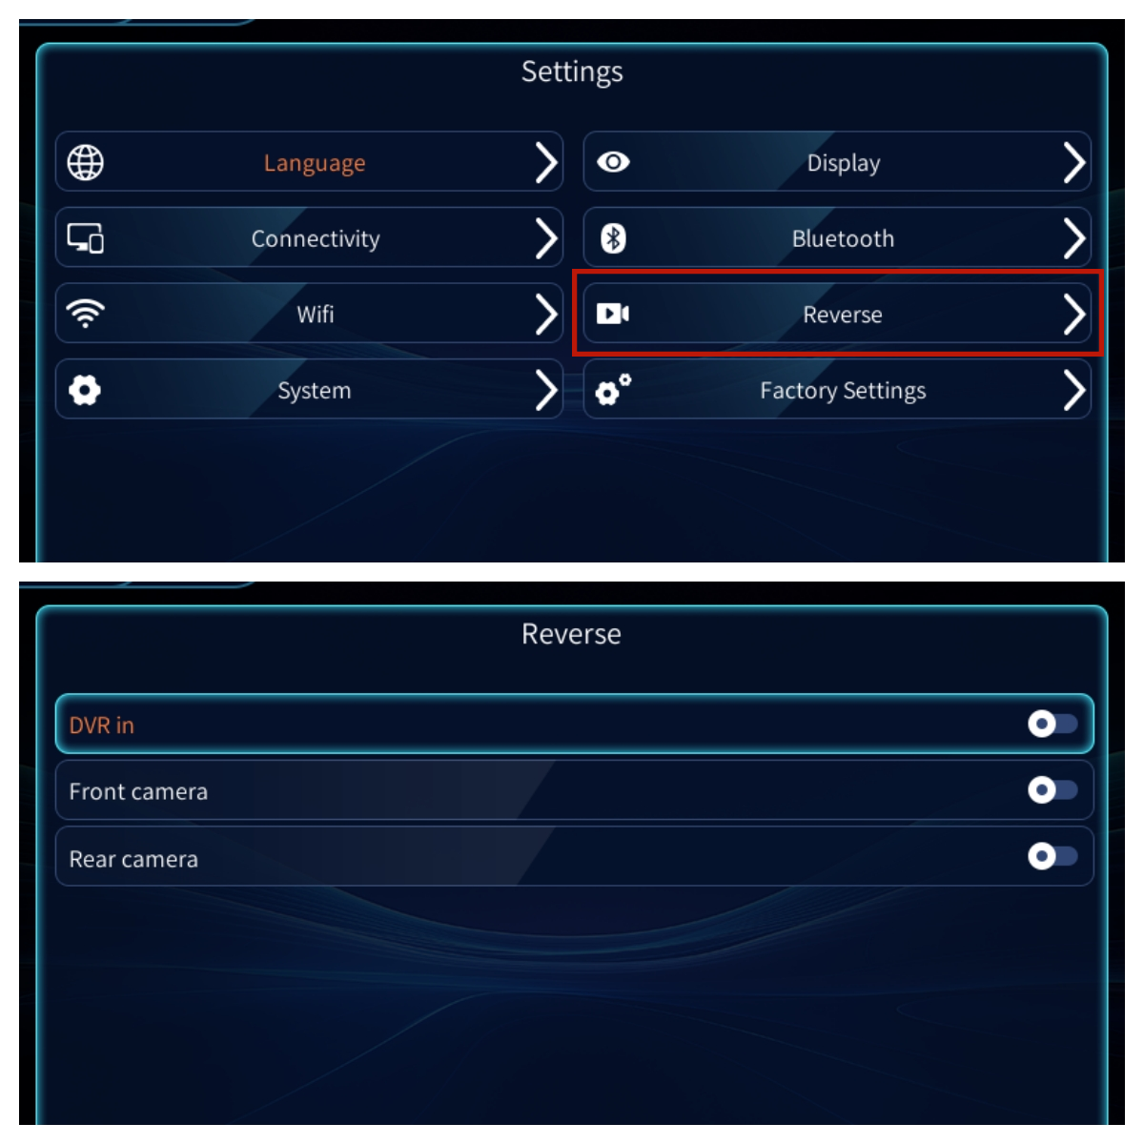
4

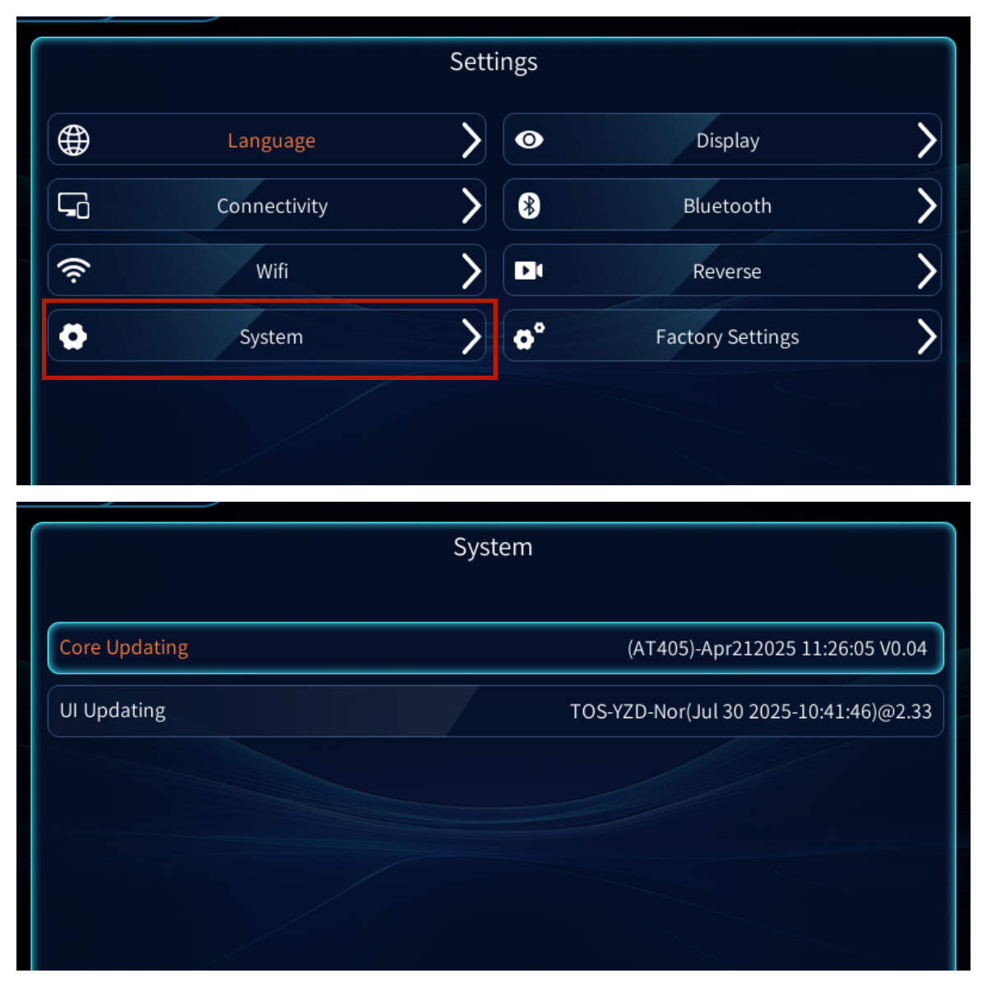
Settings - System upgrade is divided into two parts: kernel and interface. Before upgrading (please disconnect your phone first), click "Wi-Fi" on the "Settings" screen, turn on your phone's hotspot (other networks are also acceptable), then return to the "System Upgrade" screen, click "Kernel Upgrade" or "Interface Upgrade", and enter your password (please consult after-sales technicians for the password), as shown in the figure:

Settings - Factory Settings - Change the vehicle logo display, restore factory settings, and more, as shown in the image:
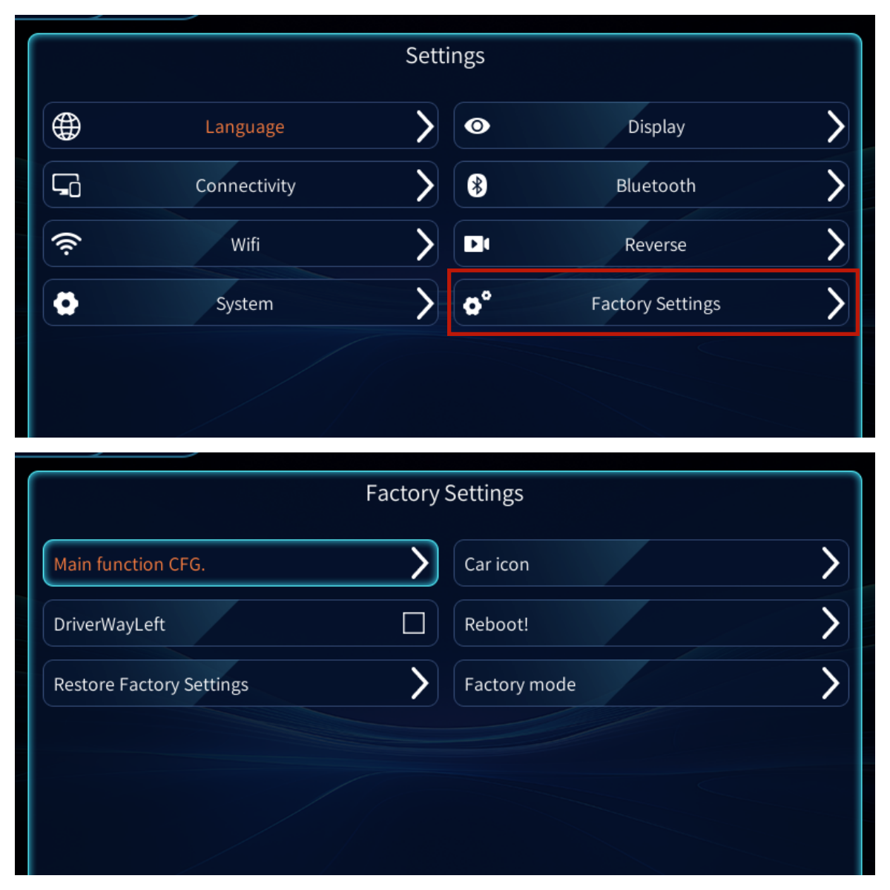
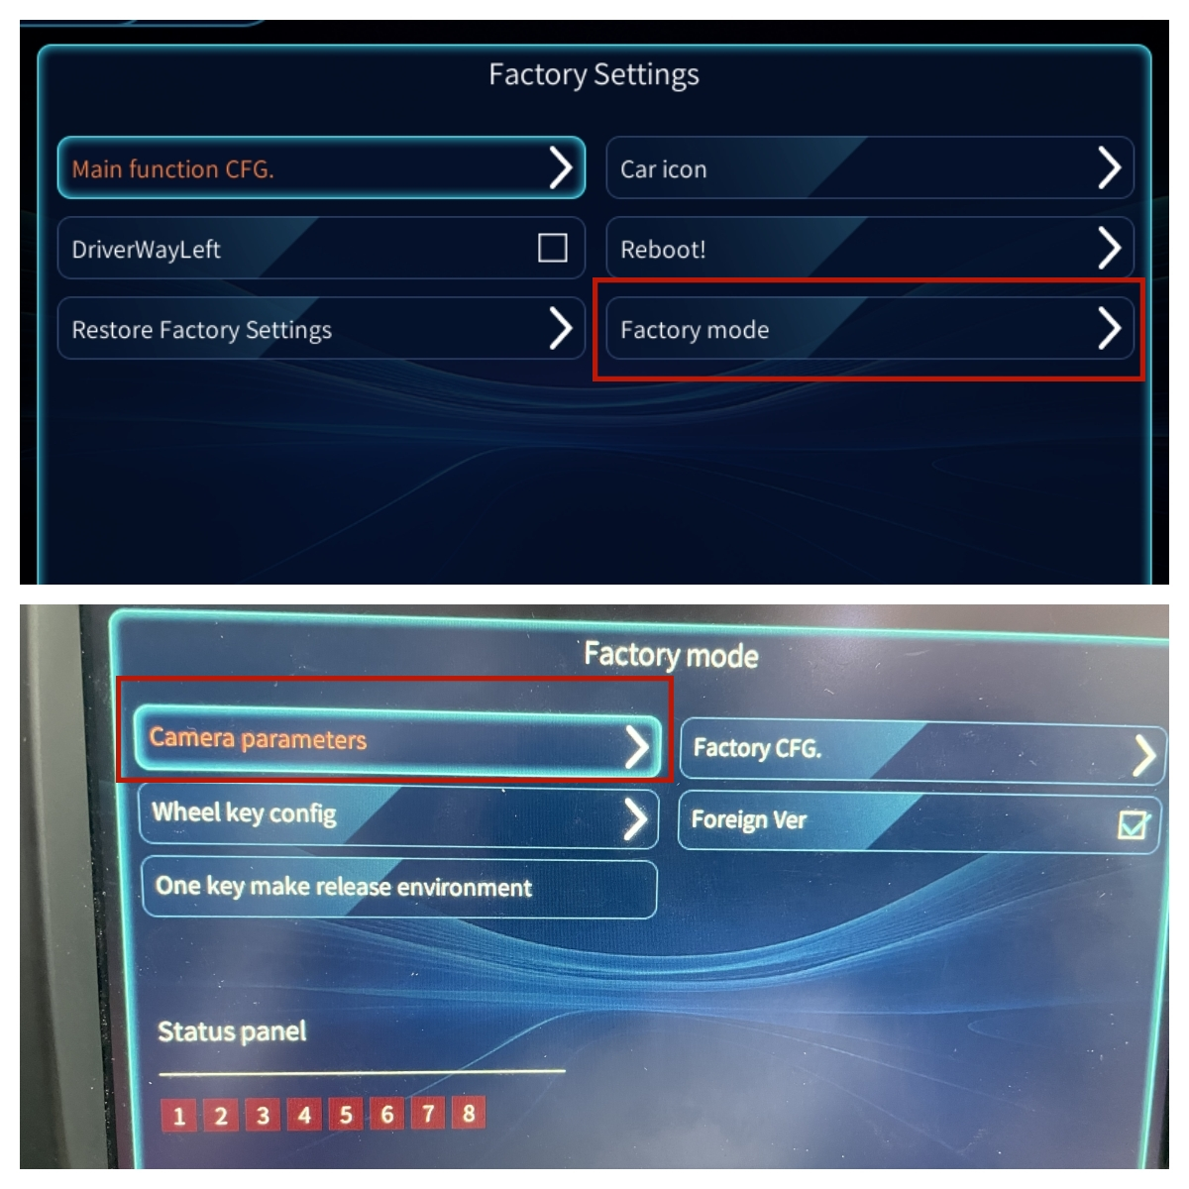
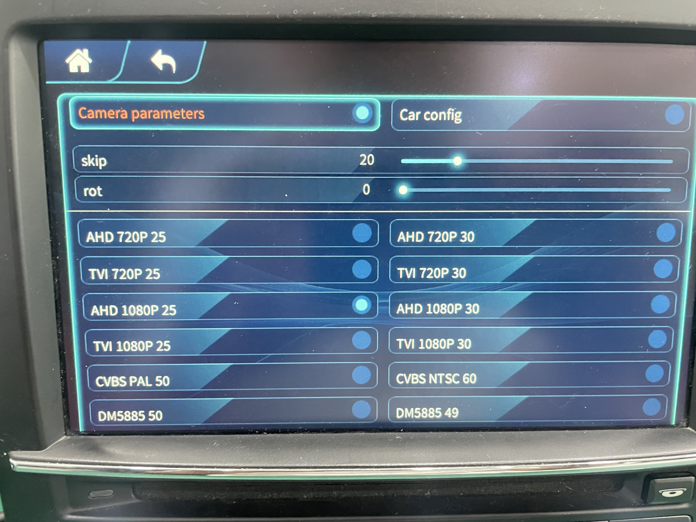
If you are modifying a reversing camera, please connect the cable correctly. And select the corresponding format according to your camera. Enter the factory mode - enter the password: 6666, camera parameters, select the parameters corresponding to your camera, as shown in the figure:
》

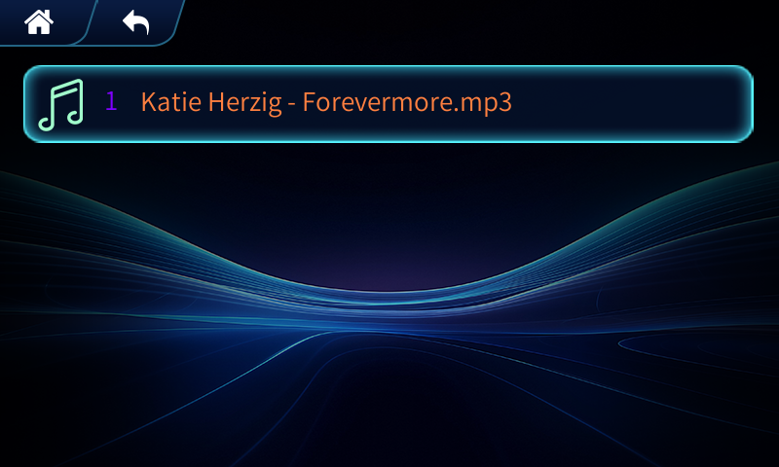
Insert the USB drive into the USB cable and click on the music on the page. The supported audio formats are: mp3, Wmv, Wav, Mid. As shown in the figure:

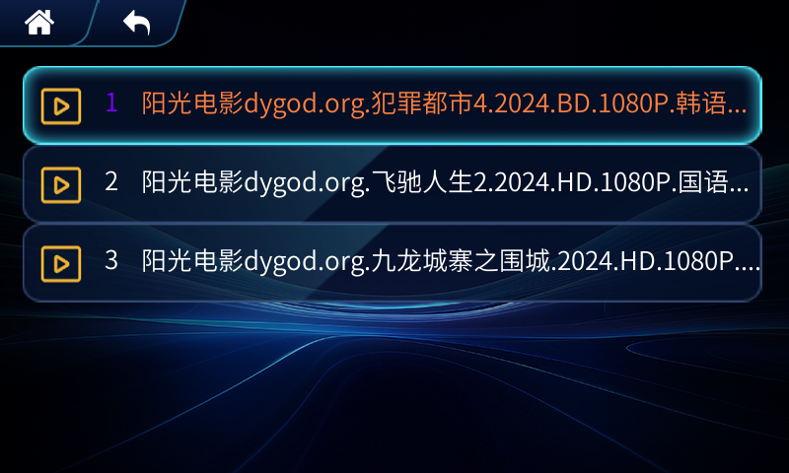
Supported video formats include: MPG, MPEG, DAT, MP4, 3GP, MOV, Rm, RAM, Rmvb, WMV, ASF, Avi, Aiff, VOB, and Ifo. (See the image below):

Common problem solving

1、CarPlay Sound Issues.
1:CarPlay uses your vehicle's AUX audio system, so you need to select AUX mode on the vehicle's media interface to play audio. Some models, such as those equipped with the Mercedes-Benz NTG4.0 and NTG4.5 systems, have two AUX modes: Audio AUX and Video AUX. Please ensure that Audio AUX mode is enabled in the vehicle's Engineering Mode to play audio.
2: Do not connect your phone to the vehicle's Bluetooth while CarPlay audio is in AUX mode. Doing so will cause audio conflicts and mute certain functions.
3:Some vehicles are equipped with an optical multimedia head unit as an in-vehicle audio source. For the original vehicle's multimedia head unit, please unplug the optical cable, plug it into our 48-pin optical power cable connector, and then plug it into the multimedia head unit. Failure to do so will result in no audio in the entire vehicle.
2、After installing the CarPlay module, why does the rearview camera display go black when the original vehicle is in reverse?
Because the vehicle module has a built-in rearview camera interface, a black screen indicates that the vehicle is in reverse. For a stock backup camera, simply turn on DIP switch 8. If you're retrofitting a backup camera, properly connect the cable to the module and turn on DIP switches 4 and 8. Also, check that the camera circuit is receiving power. For manual transmission vehicles, connect the 12V power cable from the backup lights to the module's rear power cable.

3、After installation, the CarPlay interface displays a black screen, a fragmented screen, or flickers.
This is caused by incorrect DIP switch settings on the side of the module. The required DIP switch sizes vary depending on the car model. Please adjust the correct DIP switches according to the manual.

4、Why can't I listen to my car radio while using CarPlay/Android Auto?
Because CarPlay uses the car's AUX audio system, which is different from the radio, the two cannot be used simultaneously. For example, you can't listen to the radio while playing Bluetooth music. If you want to listen to the radio while using CarPlay, we recommend downloading a radio app on your phone and using that app on the CarPlay/Android Auto interface.

5、Why can't my phone connect, and the connection screen keeps scrolling?
1: iPhone: Check your phone's Bluetooth pairing list to make sure all Bluetooth names are cleared, leaving only the device's Bluetooth name. Then try to reconnect. Keep both Bluetooth and Wi-Fi turned on while connecting.
If the connection issue persists, keep Wi-Fi and Bluetooth turned on on your phone and restart it. Alternatively, you can restore your phone's network settings.

The network and traffic used by the car system come from the mobile phone.When
connecting the car system to wireless CarPlay,the first time it is necessary to manually
connect the car Bluetooth to the phone Bluetooth and keep the phone Bluetooth on.After a successful CarPlay connection,the Bluetooth connection between the phone and the
system will automatically disconnect,and then enter the WIFI authentication channel.The in car system will actively identify dedicated hotspots and transmit pop-up windows to the in car display screen.To install an iPhone wired connection,simply plug in your phone's
data cable to complete the connection.

About driving
Drivers should not operate the machine during driving to avoid affecting safe driving and causing traffic accidents.Safety first,smart entertainment secondplease strictly abide by national traffic
regulations!

Postscript
At this point,you have gained a comprehensive and easy-to-use understanding of in car system software.You can now operate the car infotainment system and experience the
convenience it brings to your driving life,enjoying the infinite fun brought by high-tech! Wishing you a smooth and safe journey!Due to continuous software upgrades,screenshots of this manual may differ from the version you are actually using,without prior notice

